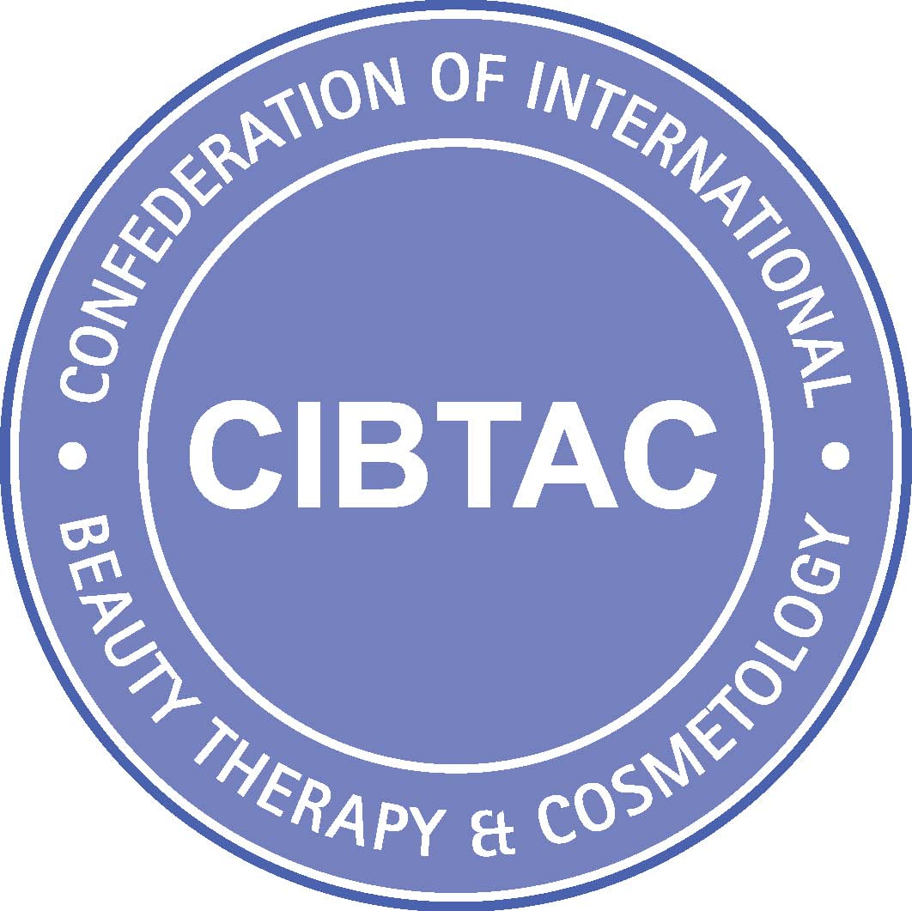

COURSE MARKING SHEET
UNIT SDT02 L4 ADVANCED SKIN SCIENCE

Use this document alongside the assessment workbook / portfolio to determine if the learner has covered all the required learning outcomes to the required standard. This is a knowledge only course.

Candidate Name: |  | CIBTAC/SDTC Registration Number:
Date of Assessment Workbook/ Portfolio Marking: |  | MCQ’s Completed & Passed (See MCQ Log)  Assessor must indicate they are completed & passed:
Course Completion Date:

Knowledge outcomes 1- 3.8 are evidenced through the completion of the course manual, the course assessment workbook, the internal MCQs and the external MCQ exam.

Learning Outcome | Assessment Criteria/Objective |  | Outcome | Referrals- If this column is ticked you will need to refer to the comments inside workbook for specific details – You will need to add to your work and re-submit
1  Understand advanced skin science and the relevance to facial aesthetic treatment. | 1.2  Explain the relevance of advanced knowledge and understanding of skin anatomy and physiology to safe and effective aesthetic practice |  | Pass  ✓ | Referral
 | 1.3  Explain the structure and function of the skin as an entire body organ |  | Pass  ✓ | Referral
 | 1.4  Demonstrate knowledge of the skin anatomy on a medical grade anatomical diagram |  | Pass  ✓ | Referral
 | 1.5  Explain the principle functions of the skin |  | Pass  ✓ | Referral
 | 1.6  Explain the development, structure, histology and function of the epidermis in relation to skin health |  | Pass  ✓ | Referral
 | 1.7  Explain the dermal appendages and circulatory systems in relation to skin health |  | Pass  ✓ | Referral
 | 1.8  Explain the process of melanogenesis |  | Pass  ✓ | Referral
2. Understand and explain advanced knowledge of the wound healing process and the relevance to facial aesthetic treatment | 2.1  Explain wound healing as it relates to the skin and non-surgical aesthetic treatment |  | Pass  ✓ | Referral
3. Understand and explain the physiology of skin the ageing and the relevance to facial aesthetic treatment | 3.1  Describe the basic principles of the physiological changes associated with skin ageing |  | Pass  ✓ | Referral
 | 3.2  Describe the signs and symptoms of an ageing skin |  | Pass  ✓ | Referral
 | 3.3  Give an overview of the influences on the healing capacity of an ageing skin |  | Pass  ✓ | Referral
 | 3.4  Explain the sources and effects of antioxidants on skin health |  | Pass  ✓ | Referral
 | 3.5  Give an overview explanation of the effects of lifestyle on the skin and free radical attack |  | Pass  ✓ | Referral
 | 3.6  Explain the causes and effects of dehydration on the skin |  | Pass  ✓ | Referral
 | 3.7  Explain how ageing effects the skin healing response and the principles of skin regenerative treatments |  | Pass  ✓ | Referral
 | 3.8  Explain the signs and  symptoms of adult acne |  | Pass  ✓ | Referral

Assessor Comments | Well done (insert learner name). You have now completed the internal assessment requirements for the CIBTAC/SDTC Level 4 Advanced Skin Science as indicted below  See the table below for full information about the course requirements  Course Assessment Protocol for  Unit SDT02 Level 4 Advanced Skin Science  Assessment Type Result  1. Internal Assessment  Course presentations - Must have been accessed and worked through  Modular MCQs - Must be passed at a minimum of 70%  Course Workbook – Must have been completed and marked as passed  2. External Assessment  MCQ Examination at your delivering centre This exam will be graded. 85% Distinction 75% Credit 60% Pass 59% and below fail CIBTAC will notify the delivering centre of results and you will then be notified from your particular centre  Presentation of your work  The external CIBTAC examiner will need to see all your work.  1. Your course workbook. This may be presented in hard copy or electronic form.  3. Evidence of passed MCQs with grades. This will be presented in electronic form  Assessor comments  Internal Assessment Evidence  1. Modular MCQs  The MCQ’s were mostly completed well/ excellently /well.  2. Course Workbook  Your work is reflective of some/ a great deal of hard work and effort clearly demonstrating some/ good/ excellent commitment and dedication to your learning and the course itself.  Your answers are sufficient/good/excellent reflecting sufficient/good/excellent understanding of the key concepts both from a theoretical and a practical perspective. You have made a sufficient/good/excellent effort to learn everything possible from the audio presentations and have been able to include some/many detailed discussions and visuals ensuring that you have a useful resource to look back on. You have also included some/good/excellent excellent additional research.  The External Assessment  1. You must attend your delivering centre to take an end of course exam. This exam will consist of a multiple-choice question paper that will reflect the total content of your elected course. This test paper will be graded Pass, Credit or Distinction.  2. You should present all your passed internal course assessment to the CIBTAC examiner. This will be done at the end external examination.  It is your responsibility to make sure you have all your course assessment evidence for the examiner.  Exam Results  Results will be sent from CIBTAC approximately 6 weeks after the exam date to your delivering centre. You will then be notified.  CIBTAC/SDTC Certification  Certification will be released when you have completed and passed the external MCQ examination and had all your internal assessment evidence checked by the CIBTAC external examiner.  Letters of Achievement  Your delivering centre may be able to provide you a letter of part achievement in the interim if you should need it. Please contact your tutor for further details.  Your course manuals and assessment evidence  Important note - Employers, other educational establishments, registering bodies and insurers may want evidence of your learning at some point in the future. Your completed assessment evidence along with your course manual and your qualification certificate, will provide you with all the evidence you may need. Keep all your work secure and in good order.  Final Tutor Comments  I would like to take this opportunity to say well done and it has been a pleasure being your tutor.  Further Advice  There has been a new registering body set up for aesthetic practitioners following the HEE recommendations of January 2016 and the more recent DoH interventions. This body is the ‘Joint Council for Cosmetic Practitioners’ (JCCP).  It will mean that for the first time both medical and non-medical practitioners carrying out aesthetic treatments will have an official registering authority. Practitioners from the beauty therapy sector will have to have minimum of accredited level 4, sector related qualifications, in addition to any skill specific manufacturer led training they may have, to gain access to the register and medical practitioners will have to verify their medical qualification in addition to any skill specific manufacturer led training.  This is very exciting and a significant step forward for all practitioners. It will go a long way to ensuring protection of the public and in addition the future of all practitioners in the sector, regardless of background. We expect this body to become more evident in the next year and significantly so over the next few years.
Assessor Name | Assessor Signature:

