The CIBTAC / Sally Durant
Level 4 Qualification Portfolio

UNIT ONE
Core Knowledge For Aesthetic Practice

UNIT ASSIGNMENT

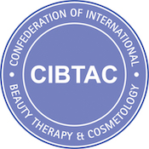

Task 1 Module 3 Section 1

Research and catalogue details of the main systemic bacterial, viral, fungal and parasitic illnesses which affect the human body as a whole.
Some of these infections have already been mentioned but there are many others you need to be aware of.
Your research should include the principle signs and symptoms of each illness and a brief indication of how it may be treated by a doctor

Use the checklists in your course notes to ensure you cover the most pertinent systemic infections

