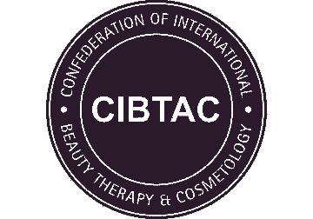
PORTFOLIO CHECKLIST
CSDD04 Level 4 Diploma in Advanced Skin Studies and Aesthetic Practice

Centre Name
Learner Name
Learner Number

 | Date Completed | Tutor Signature
Core Knowledge
Advanced Skin Science
Investigative Consultation
Chemical Skin Peeling
Micro-Needling
Blemish Removal
Case Studies: Chemical Skin Peeling, Micro Needling, Blemish Removal, Investigative Consultation(Found within other Case Studies)

DECLARATION
I confirm that the evidence provided is as a result of my own work and where necessary any quotes or references have been clearly identified as such.
Signature of Learner |  | Date

