DATE OF
TREATMENT
____________
CLIENT REF

__________

INFORMED CONSENT

BLEMISH REMOVAL BY THERMOLYSIS
& CRYOTHERAPY

Client Ref
________________

Practitioner name
_________________

Date
________________

COMPANY LOGO / COMPANY NAME / PRACTITIONER NAME

COMPANY LOGO / COMPANY NAME / PRACTITONER NAME

TREATMENT INFORMATION

BLEMISH REMOVAL BY SHORT WAVE DIATHERMY

Treatment Introduction

Non-Surgical Blemish Removal is a very safe, effective, and quick procedure involving the removal of: Telangiectasia (red veins), Spider Naevi, Skin Tags, Blood Spots, Seborrheic Keratosis, Milia, Hairy Moles and Viral Warts using electrical currents. It is commonly known as advanced electrolysis and has traditionally been carried out by beauty therapists who have initially qualified in electrolysis hair removal and then moved into this area of advanced practice. However with the rapid growth of the clinical aesthetic industry these treatment are now carried out by aesthetic doctors, nurses, dentists or those with other suitable clinical backgrounds.

How it works

The treatment uses a Short Wave Diathermy electrical current which passes heat into the skin. This cauterises the tissue to seal surface blood vessels or to lift away excessively keratinised lesions

Telangiectasia or thread veins are skin capillaries which have lost their ability to constrict back into the skin are like the fine twigs on the branches of a tree the blood is merely diverted to an alternative ‘branch’ or capillary and the blood supply to the tissues remains fully functional. The same techniques are used for spider naevi and cherry angiomas or blood spots. The removal of thread veins with advanced electrolysis is generally permanent but further damaged vessels can arise subsequently to take their place depending on the skin condition and the extrinsic and intrinsic factors which influence the skin’s sensitivity.

For the removal of seborrheic warts, viral warts and skin tags the short wave diathermy current cauterizes and cuts through the tissue with its subsequent removal. The blood supply to nourish any further growth of the lesion is sealed off and the blemish will heal fully within a few days to a couple of weeks leaving minimal, if any, marking at all to the skin. The permanent removal of these lesions is generally achieved in one or possibly two treatments depending on their size

Milia are treated by short wave diathermy only. The fatty content of these lesions is vapourised and the milia will clear without marking the skin. If the lipid dryness of the skin is not addressed or regular exfoliation is not undertaken, these lesions can reoccur

What does the treatment involve? Does it hurt?

A very fine needle probe is used to pass the heat of the electrical current into the tissue. This is so fine and localized that only the smallest amount of discomfort is experienced and for most people there is very little discomfort.

What are the side effects?

For a few days the area treated will be sensitive, show redness and a little swelling and for the deeper lesions there may be scabbing. Provided that the correct aftercare instruction is followed and no infection is allowed to develop, the risks of any scarring are minimal. Some of the deeper lesions may however leave a feint residual pink mark on lighter skins or a deeper pigmented area on darker skins. You must notify the training centre / your practitioner if you are prone to post inflammatory hyperpigmentation, raised scarring or keloid scarring as these issues will either contraindicate or restrict your treatment.

COMPANY LOGO / COMPANY NAME / PRACTITONER NAME

TREATMENT INFORMATION

BLEMISH REMOVAL BY CROTHERAPY

Treatment Introduction

Non-Surgical Blemish Removal by cryotheraoy is a very safe, effective, and quick procedure involving the removal of flat pigmentation marks, warts and verrucae . It may also be used for Skin Tags, Blood Spots, Seborrheic Keratosis and Milia. is commonly known as advanced electrolysis and has traditionally been carried out by beauty therapists who have initially qualified in electrolysis hair removal and then moved into this area of advanced practice. However with the rapid growth of the clinical aesthetic industry these treatment are now carried out by aesthetic doctors, nurses, dentists or those with other suitable clinical backgrounds.

How it works

This technique has been used medically for decades and uses liquid Nitrogen or Nitrous Oxide gas to freeze the unwanted tissue and so destroy it.

What does the treatment involve? Does it hurt?

The area to be treated will be wiped with a skin sanitising solution. Your practitioner will show you the cryotherapy device which looks like a large pen. The nitrous oxide gas will flow in a narrow jet for the end of the pen and you will see it a cloudy white jet. You may also hear a quiet hissing noise. AS the treatment is applied to your skin you will feel a mild sharpness and a cold burning sensation – a little like an burn when you hold an ice cube. Immediately the tissue being treated will turn white as the frosting takes place.

What are the side effects?

For a few days the area treated will be sensitive, show redness and a little swelling and for the deeper lesions there may be scabbing. In cases of deeper treatment there may be slight blistering but it is essential that you do not burst these blisters infection may then occur. However provided that the correct aftercare instruction is followed in all cases, and no infection is allowed to develop, the risks of any scarring are minimal. Some of the deeper lesions may however leave a feint residual pink mark on lighter skins or a deeper pigmented area on darker skins. You must notify the training centre / your practitioner if you are prone to post inflammatory hyperpigmentation, raised scarring or keloid scarring as these issues will either contraindicate or restrict your treatment.

COMPANY LOGO / COMPANY NAME / PRACTITONER NAME

TREATMENT AFTERCARE ADVICE

BLEMISH REMOVAL BY SHORT WAVE DIATHERMY

- After a short wave diathermy the area may feel warm and tingling for a few hours. If the sensation is one of burning or stinging, or persists beyond the first 24 – 48 hours then you should contact the training centre / your practitioner
- The treated lesion may scab or weep slightly – this is a normal healing reaction
- Where blood vessels have been treated you may find that the vessel shows darker for a few days after the procedure – this is the blood drying in the sealed vessel and will fade with time.
- If the area become increasingly painful, the surrounding skin becomes inflamed or swollen or you have any other concerns you should contact the training centre / your practitioner.

BLEMISH REMOVAL BY CRYOTHERAPY

- Blemishes treated by cryotherapy will usually go darker after the procedure and feel tender or sore for a 24 – 48 hours.
- In some cases blistering can occur. If so do not burst the blister as this will risk infection. If the blister does burst apply antiseptic and cover the lesion with a sterile dressing or Elastoplast.
- If the area become increasingly painful, the surrounding skin becomes inflamed or swollen or you have any other concerns you should contact the training centre / your practitioner.

HOMECARE PROCEDURES – BOTH TREATMENT MODALITIES

- Keep the area clean using a sterile saline, cooled boiled water or mild antiseptic solution such as witch hazel or savlon wash. Apply an antiseptic gel or cream as required
- If required, protect the area with a sterile dressing or elastoplast, for the next few days until the area has formed a scab. This will apply mostly to seborrheic warts and skin tags.
- Do not touch or pick at the area.
- Avoid exposing the area to any extremes of heat or extreme cold (tepid warm water only)
- Avoid harsh, perfumed, astringent or alcohol containing products in the area
- Do not go swimming in a chlorinated pool for one week
- Do not have any other clinical skin treatment until the lesion has fully healed and always make your skin care practitioner aware of the fact that you have received this procedure and the date it was provided.
- Avoid make up on the area for 24 hours unless of the mineral makeup type specifically formulated for post procedural application
- To give your skin the best chance of full and rapid healing do not put your body’s resources under undue strain for the next few days eg excessive gym work, other regenerative treatments, laser / IPL hair removal etc as this will overload the wound healing responses of the body and therefore your skin will struggle to recover.
- Contact the training centre / Your practitioner immediately if you have any concerns regarding your treatment so that we may advise you accordingly

Client Confirmation

- I have read and understand the above instructions for the aftercare procedures I am required to follow. I accept responsibility for compliance with these instructions and understand that the results of the treatment procedure provided to me today will be negatively impacted if I act against this instruction.
- I confirm that I have been given a copy of these instructions.
- I have been provided with the contact details for my practitioner should I need to contact them in respect of my treatment or any concerns that I may have.

Client Signature ___________________________________________ Date __________________________________

Print Name ________________________________________________

IN THE CASE OF ANY CONCERNS OR QUESTIONS THAT YOU MAY HAVE FOLLOWING YOUR
TREATMENT PLEASE CONTACT

COMPANY / PRACTITIONER EMAIL AND TELEPHONE NUMBER

COMPANY LOGO / COMPANY NAME / PRACTITONER NAME

PHOTOGRAPH CONSENT

Photographs To Monitor Skin Change

Taking pre and post treatments photographs to monitor treatment progress and success is a ‘best practice’ procedure.

We would like to request your permission and consent to take photographs and /or video for the purpose as described above. These photographs or video will be securely stored, kept confidential and access will only be permitted to authorised personnel.

Please sign and date below.

I hereby give consent to the taking of photographs that will be used to monitor treatment progress and success only.

Name (Please print) ____________________________________________________

Signature ______________________________________________________________ Date __________

Photographs for Training / Marketing Purposes

Pre and post treatment photos & video are really useful for us to use in our training and marketing materials and we would like to use your images for this purpose also. We would not give any personal information including names, unless your consent was specifically given.

We would like to request your permission and consent to use your photographs and video for the purpose described above. These photographs or video will be securely stored but used for training purposes only

Training Purposes Marketing Purposes

Please sign and date below.

I hereby give consent to the use of the photographs & video taken of me for training purposes.

Name (Please print) ____________________________________________________

Signature ______________________________________________________________ Date __________

GDPR CONSENT

I confirm that I have been advised of the company’s policy for GDPR Compliance, and my rights under this legislation, and consent to the secure storage of my data

Client Name (Print) _______________________________________________________________________________

Client Signature _________________________________________________________ Date_________________

COMPANY LOGO / COMPANY NAME / PRACTITONER NAME

INFORMED CONSENT TO BLEMISH REMOVAL TREATMENT

I can confirm that the information I have given on my Client Consultation form, which I have validated (or revalidated) on ……………….….(date), is, to the best of my knowledge complete and correct. I have fully disclosed all the information asked of me and have not withheld any known medical history or condition.

I understand that the conditions listed in the consultation form and consent form can make me unsuitable for the required treatment. It is my responsibility to inform the training centre / my practitioner if my circumstances change, on each and every visit for treatment.

I understand that the person providing my treatment is training in the procedure I am to receive today

I have been fully informed about the procedure I am to receive including the possible side effects and the aftercare procedures I must follow. I have been given the opportunity to ask any question I may have and have received satisfactory answers to these questions.

I have been provided with the aftercare instructions relating to this procedure and understand that any failure on my part to adhere to these instructions could result in an adverse skin reaction, poor result or skin damage. I have been provided with an emergency contact telephone number / email address.

I freely assume responsibility for any risks of complications or injury from known or unknown causes associated with, relating to, or otherwise arising out of this procedure.

I understand that the General Medical Council advise that General Practitioners are kept fully informed about all treatments undertaken by their patients. Either I have informed my General Practitioner, or, in signing this form I am exercising my right not to inform my General Practitioner about the treatment I am about to undertake.

I have read and understood this consent form, all the above matters have been explained to me and my questions have been addressed and answered to my satisfaction.

I hereby consent to the blemish removal treatment being undertaken.

Client Name (Print) _______________________________________________________________________________

Client Signature _________________________________________________________ Date_________________

Practitioner Name _______________________________________________________________________________

Practitioner Signature __________________________________________________________ Date ________________

Tutor Name _______________________________________________________________________________

Tutor Signature ___________________________________________________________Date ________________

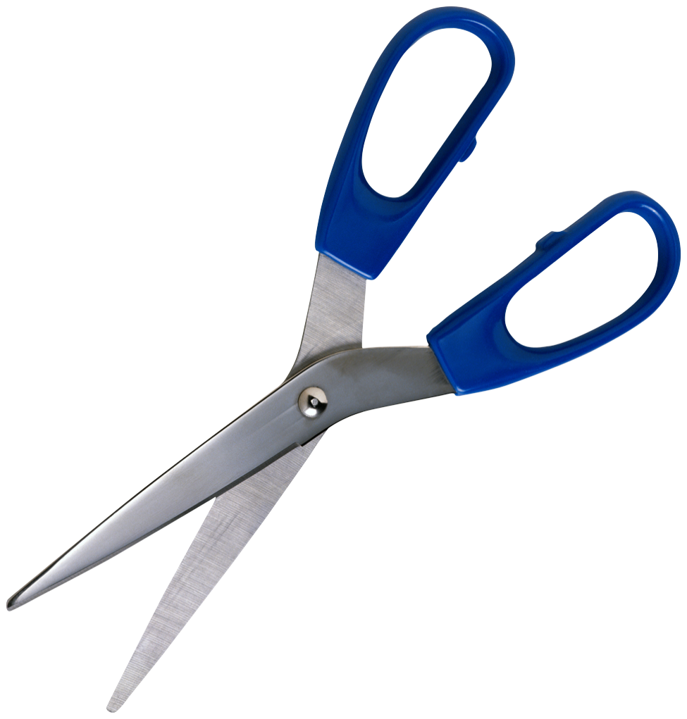
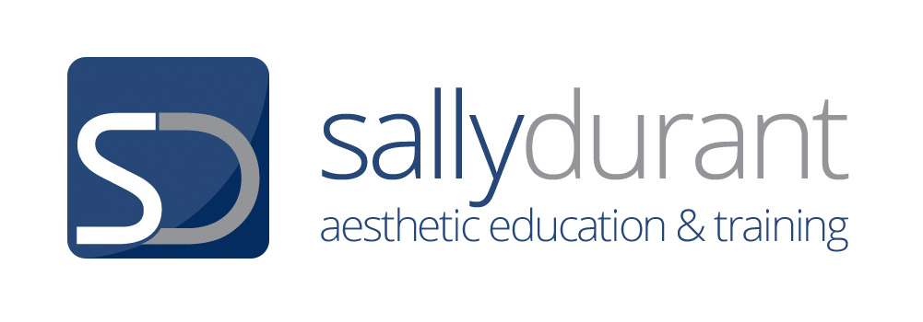
CLIENT COPY

TREATMENT INFORMATION

BLEMISH REMOVAL BY SHORT WAVE DIATHERMY

Treatment Introduction

Non-Surgical Blemish Removal is a very safe, effective, and quick procedure involving the removal of: Telangiectasia (red veins), Spider Naevi, Skin Tags, Blood Spots, Seborrheic Keratosis, Milia, Hairy Moles and Viral Warts using electrical currents. It is commonly known as advanced electrolysis and has traditionally been carried out by beauty therapists who have initially qualified in electrolysis hair removal and then moved into this area of advanced practice. However with the rapid growth of the clinical aesthetic industry these treatment are now carried out by aesthetic doctors, nurses, dentists or those with other suitable clinical backgrounds.

How it works

The treatment uses a Short Wave Diathermy electrical current which passes heat into the skin. This cauterises the tissue to seal surface blood vessels or to lift away excessively keratinised lesions

Telangiectasia or thread veins are skin capillaries which have lost their ability to constrict back into the skin are like the fine twigs on the branches of a tree the blood is merely diverted to an alternative ‘branch’ or capillary and the blood supply to the tissues remains fully functional. The same techniques are used for spider naevi and cherry angiomas or blood spots. The removal of thread veins with advanced electrolysis is generally permanent but further damaged vessels can arise subsequently to take their place depending on the skin condition and the extrinsic and intrinsic factors which influence the skin’s sensitivity.

For the removal of seborrheic warts, viral warts and skin tags the short wave diathermy current cauterizes and cuts through the tissue with its subsequent removal. The blood supply to nourish any further growth of the lesion is sealed off and the blemish will heal fully within a few days to a couple of weeks leaving minimal, if any, marking at all to the skin. The permanent removal of these lesions is generally achieved in one or possibly two treatments depending on their size

Milia are treated by short wave diathermy only. The fatty content of these lesions is vapourised and the milia will clear without marking the skin. If the lipid dryness of the skin is not addressed or regular exfoliation is not undertaken, these lesions can reoccur

What does the treatment involve? Does it hurt?

A very fine needle probe is used to pass the heat of the electrical current into the tissue. This is so fine and localized that only the smallest amount of discomfort is experienced and for most people there is very little discomfort.

What are the side effects?

For a few days the area treated will be sensitive, show redness and a little swelling and for the deeper lesions there may be scabbing. Provided that the correct aftercare instruction is followed and no infection is allowed to develop, the risks of any scarring are minimal. Some of the deeper lesions may however leave a feint residual pink mark on lighter skins or a deeper pigmented area on darker skins. You must notify the training centre / your practitioner if you are prone to post inflammatory hyperpigmentation, raised scarring or keloid scarring as these issues will either contraindicate or restrict your treatment.

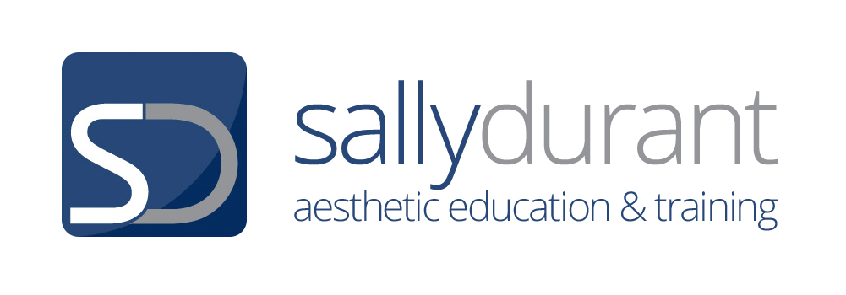
CLIENT COPY

TREATMENT INFORMATION

BLEMISH REMOVAL BY CROTHERAPY

Treatment Introduction

Non-Surgical Blemish Removal by cryotheraoy is a very safe, effective, and quick procedure involving the removal of flat pigmentation marks, warts and verrucae . It may also be used for Skin Tags, Blood Spots, Seborrheic Keratosis and Milia. is commonly known as advanced electrolysis and has traditionally been carried out by beauty therapists who have initially qualified in electrolysis hair removal and then moved into this area of advanced practice. However with the rapid growth of the clinical aesthetic industry these treatment are now carried out by aesthetic doctors, nurses, dentists or those with other suitable clinical backgrounds.

How it works

This technique has been used medically for decades and uses liquid Nitrogen or Nitrous Oxide gas to freeze the unwanted tissue and so destroy it.

What does the treatment involve? Does it hurt?

The area to be treated will be wiped with a skin sanitising solution. Your practitioner will show you the cryotherapy device which looks like a large pen. The nitrous oxide gas will flow in a narrow jet for the end of the pen and you will see it a cloudy white jet. You may also hear a quiet hissing noise. AS the treatment is applied to your skin you will feel a mild sharpness and a cold burning sensation – a little like an burn when you hold an ice cube. Immediately the tissue being treated will turn white as the frosting takes place.

What are the side effects?

For a few days the area treated will be sensitive, show redness and a little swelling and for the deeper lesions there may be scabbing. In cases of deeper treatment there may be slight blistering but it is essential that you do not burst these blisters infection may then occur. However provided that the correct aftercare instruction is followed in all cases, and no infection is allowed to develop, the risks of any scarring are minimal. Some of the deeper lesions may however leave a feint residual pink mark on lighter skins or a deeper pigmented area on darker skins. You must notify the training centre / your practitioner if you are prone to post inflammatory hyperpigmentation, raised scarring or keloid scarring as these issues will either contraindicate or restrict your treatment.

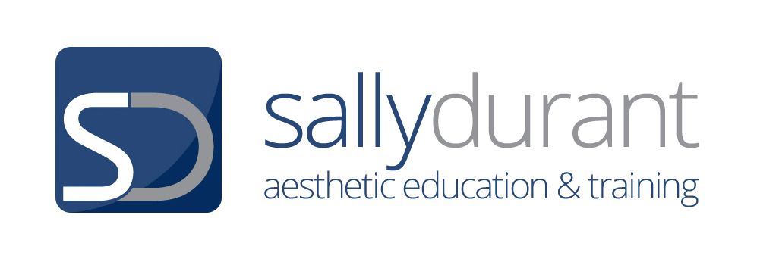
CLIENT COPY

TREATMENT AFTERCARE ADVICE

BLEMISH REMOVAL BY SHORT WAVE DIATHERMY

- After a short wave diathermy the area may feel warm and tingling for a few hours. If the sensation is one of burning or stinging, or persists beyond the first 24 – 48 hours then you should contact the training centre / your practitioner
- The treated lesion may scab or weep slightly – this is a normal healing reaction
- Where blood vessels have been treated you may find that the vessel shows darker for a few days after the procedure – this is the blood drying in the sealed vessel and will fade with time.
- If the area become increasingly painful, the surrounding skin becomes inflamed or swollen or you have any other concerns you should contact the training centre / your practitioner.

BLEMISH REMOVAL BY CRYOTHERAPY

- Blemishes treated by cryotherapy will usually go darker after the procedure and feel tender or sore for a 24 – 48 hours.
- In some cases blistering can occur. If so do not burst the blister as this will risk infection. If the blister does burst apply antiseptic and cover the lesion with a sterile dressing or Elastoplast.
- If the area become increasingly painful, the surrounding skin becomes inflamed or swollen or you have any other concerns you should contact the training centre / your practitioner.

HOMECARE PROCEDURES – BOTH TREATMENT MODALITIES

- Keep the area clean using a sterile saline, cooled boiled water or mild antiseptic solution such as witch hazel or savlon wash. Apply an antiseptic gel or cream as required
- If required, protect the area with a sterile dressing or elastoplast, for the next few days until the area has formed a scab. This will apply mostly to seborrheic warts and skin tags.
- Do not touch or pick at the area.
- Avoid exposing the area to any extremes of heat or extreme cold (tepid warm water only)
- Avoid harsh, perfumed, astringent or alcohol containing products in the area
- Do not go swimming in a chlorinated pool for one week
- Do not have any other clinical skin treatment until the lesion has fully healed and always make your skin care practitioner aware of the fact that you have received this procedure and the date it was provided.
- Avoid make up on the area for 24 hours unless of the mineral makeup type specifically formulated for post procedural application
- To give your skin the best chance of full and rapid healing do not put your body’s resources under undue strain for the next few days eg excessive gym work, other regenerative treatments, laser / IPL hair removal etc as this will overload the wound healing responses of the body and therefore your skin will struggle to recover.
- Contact the training centre / your practitionerimmediately if you have any concerns regarding your treatment so that we may advise you accordingly

Client Confirmation

- I have read and understand the above instructions for the aftercare procedures I am required to follow. I accept responsibility for compliance with these instructions and understand that the results of the treatment procedure provided to me today will be negatively impacted if I act against this instruction.
- I confirm that I have been given a copy of these instructions.
- I have been provided with the contact details for the training centre / your practitioner should I need to contact them in respect of my treatment or any concerns that I may have.

Client Signature ___________________________________________ Date __________________________________

Print Name ________________________________________________

COMPANY / PRACTITIONER EMAIL AND TELEPHONE NUMBER

