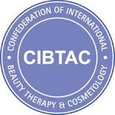
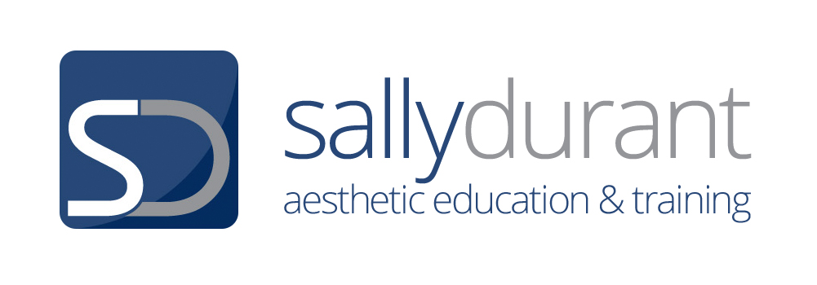

LESSON PLAN

Unit  SDP02 Provide Micro-Needling Treatment | Venue and Room | Class Details- Times & dates (where needed)  Registration:  Class:
Lesson Ref – Practical skills. Lesson Title – Micro-Needling - Practical Skill Learning & Competency Assessment

Pre Class Preparation- Lecturer  Liaise with clinic staff to  1. Ensure all H&S checks have been made & general disinfection procedures have been carried out  2. Order generic sundry items and Course specific products  3. Book all volunteer clients as required for learner numbers  3. Check volunteer client availability prior to class & make adaptations to the lesson plan to accommodate learner numbers and assessment requirements  4. Facilitate the printing of all required documents  5. Ensure all PowerPoint’s are available | Pre class preparation- Learner  1. Learners need to have covered all on line underpinning knowledge and passed all MCQ tests and documented this in the assessment workbook  2. Learners must have completed or be working towards completion of the Assessment Workbook  3. Learners must bring the Course manual with them to practical  4. Learners must be prepared for practical and have an appropriate uniform to wear and be professionally presented | Class requirements & Resources  1. Clinic resources  2. MN products  Sundry items  3. Clients for treatments- scheduled in accordance with lesson plan  4. PPTS for pertinent underpinning knowledge reviews & Practical skills  5. Hard copies of-  a) Aims & objectives for the day  b) Dermal Rollering Procedures  c) Client consultation documents  d) Assessment and feedback paperwork  6. Delegate lunch and drinks
Learning Outcomes

Underpinning knowledge
LO 1 Understand the effects and benefits of treatment, the indications for treatment and contraindications
LO 2 Understand the characteristics and effects of equipment and products required for Micro-Needling treatments
LO 3 Understand anatomy and physiology as it relates to Micro-Needling Treatment
LO 4 Understand the practical requirements for safe and effective Micro-Needling Treatment

Practical skill
LO 5 Provide ethical, safe and effective Micro-Needling treatment ensuring maintenance of health and safety practices, security and emergency procedures
LO 6 Document and conclude treatments in accordance with legislative and organisational requirements

Assessment Methods

Underpinning knowledge

1. On line MCQS- Completed prior to the practical learning and assessment session
2. Discussions, Oral questions used to reinforce and check underpinning knowledge particularly pertinent to the practical skill
3. Manual check (if appropriate)

Practical Skill Competencies- Realistic Working Environment

1. Observation of Learner preparing for and carrying out all skill competencies
2. Review of Learners written reflection and evaluation
3. Client feedback- Verbal & Written

Adaptations and differentiation
Adaptations and differentiation practices will be carried out through the learning and assessment procedures- for promoting British values, safeguarding, learning need, ability, understanding, gender, age, culture, language, and any other variance.

Methods

- Learners moved, assisted, additional support
- Questions re-phrased and simplified
- Word meanings explained
- Diagrammatic illustrations given where required
- Practical skills directed in accordance with individual needs
- Varying Food requirements

Time & Transition details | Teaching & Assessment method | Content | Learner Activity
9.00 | Registration
9.15  Introductions, housekeeping, outline of the days timetable and objectives | Discussion  Answering Questions  Use of White board or hand-out to outline objectives | Staff and SD organisation  Housekeeping  Aims and Objectives hand-out content | Listening. Q & A, Hand-out
9.30  Portfolio & course requirements review | Observation of Portfolio  Discussions and review of progress with underpinning knowledge & Course requirements.  Q&A | Progress re - Establish completion of underpinning knowledge.  Course requirements - in relation to the underpinning knowledge, assessment book completion and the portfolio and practical skills. | Review of own portfolio,  Q & A  Portfolio Exercise Completion (where applicable)
9.45  Discussions & Oral Questions to reinforce pertinent underpinning knowledge | Observation of Portfolio  Go through each module of the course picking out the most pertinent elements of underpinning knowledge.  Discussions | Legislation- H&S and pertinent elements- COSHH & clinical and sharps waste Insurance requirements-  Skin conditions to be treated  Consultation and Contraindications  The physiological impact of needling on the skin and the wound healing response and comparisons with other wounding treatments  The importance of pre-priming the Skin & readiness for treatment & care of the skin post treatment  At risk client groups | Observation and Review of own portfolio,  Q & A  Portfolio Exercise Completion (where applicable)
10.30  micro-needling procedures  Drinks will be facilitated during this period | Use of Power Point presentations or Hand-outs  Discussion  Q & A | Overview of the skin needling treatment protocol including - products that are required for treatment – cleansers, anaesthetic, disinfectant and topical treatment actives used to enhance treatment & procedures. Client comfort and adaptations, leaving blood on the skin until the treatment is completed. | Listening.  Q & A  Observation of roller presentation and /or hard copy of procedures
11.00  Consultation & micro-needling Demonstration & discussions | Client number one -  Demonstrations  Discussions  Q & A  Facilitation of learner engagement to ensure readiness for formative assessment.  Note - For best use of time. Prepare client for treatment- cleanse and apply anaesthetic, assuming treatment can go ahead- then whilst the anaesthetic is activating on the skin carry out the consultation. | Client number one  1. Demonstrate and discuss best practice approach to clients during the preparation stage- Professional and effective care and attention to modesty, health and safety and adaptations for individual groups  2. Demonstrate best practice use of towels, pillows, tissue and bedding to ensure client comfort throughout the treatment  3. The importance of client care throughout the treatment and appropriate client engagement.  4. Demonstrate cleansing Preparation of the skin for micro-needling  5. Take photograph  6. Demonstrate application of anaesthetic product.  7. Whilst the anaesthetic is on the skin – (leave for 30 minutes) - Demonstrate Consultation procedures & gaining informed consent (treatment explanations and after care an imperative element to have given) to treatment & Photograph consent.  8. Demonstrate removal of anaesthetic, skin disinfection and application of growth factor product.  9. Discuss roller & stamp choice and show removal from packets.  10. Demonstrate a micro-needling treatment. Invite delegates to hold the roller and make a few rolls over the skin in preparation for the formative summative assessment to come.  11. Post treatment procedures- cleansing of the skin & application of actives to assist the healing process, soothing and calming and skin protection post treatment.  12. Post treatment photograph.  12. After care, product and treatment recommendations, making appointments and establishing client satisfaction.  12. Documentation procedures in accordance with data protection and organisational procedures  13. post treatment cleaning and sterilisation procedures | Observation  Listening  Q & A  Engagement with practical procedures (when invited)  Reflective learning sheets
12.30 Lunch

1.30  Preparation for RWE | Discussions  Review of the assessment process and paperwork  Consultation documents  Informed consent  Photograph consent |  | Listening, Q&A, Discussions
1.45  Client session For assessment | Facilitate 2-3 x assessment opportunities.  Client number one formative practice and guided learning.  Clients 2 & 3 Summative assessment.  Observation, guidance & Assessment of the process.  Observation of –  1. Client and practitioner introductions and relationships throughout the treatment.  2. Consultation and acquisition of the consent for treatment and photographs  3. Preparation of the client including giving instructions, modesty, safety, and establishing client comfort on the couch.  4. Preparation of the skin for treatment and taking photograph  5. Removal of rollers and application of growth factor  6. Roller treatment (see competency assessment marking sheet for full parameters to be observed)  8. Post treatment cleansing and cooling of the skin  9. Post treatment product choices and application  10. Post treatment photograph  11. Provision of after care, further appointments, treatment evaluation, Client satisfaction  12. Treatment documentation procedures.  13. Disposal of sharps and contaminated waste.  note- Learners must achieve summative assessments in roller procedures with 2 clients.  note- Learners must select rollers and stamps in accordance with client needs but must ideally carry out treatments with three different needle lengths  note- learners must achieve one summative assessment for consultation and acquisition of informed consent- (see competency assessment marking sheet for full parameters to be observed) | Facilitate 2-3 x assessment opportunities.  Suggested timings for clients  1.45  3.15  4.45  Use of competency assessment marking sheet is essential. | Learners will carry out all treatment procedures For practice of skill competency acquisition, with trainer direction and for assessment of skill competency and complete all paperwork required by the awarding and delivering bodies.  Note - For best use of time. Learners will Prepare client for treatment- cleanse and apply anaesthetic, assuming treatment can go ahead- then whilst the anaesthetic is activating on the skin carry out the consultation.  Learners will -  1. Escort clients to the treatment room/ area and give instructions to them for treatment, adapting for different client groups. (age, ability, gender, race and culture)  2. Ensure readiness for treatment  3. Prepare the skin for treatment- Cleanse - ask if consent for photographs will be given- take photograph.  4. Apply anaesthetic-  5. Carry out a consultation and acquisition of informed consent to treatment and photographic consent.  6. Time anaesthetic to ensure it is left on the skin for 30 minutes.  7. Remove anaesthetic and apply growth factor product  8. Select 0.5 roller  9. Carry out treatment (see competency assessment marking sheet for full parameters to be observed)  10. Dispose of roller to sharps container  11. Cool and cleanse the skin.  12. Apply post treatment actives  13. Take post treatment photograph  14. Provide after care, product recommendations, treatment recommendations & Evaluate the client response to treatment.  15. Dispose of blood contaminated waste into the appropriate container.  16. Complete all documentation in accordance with data protection and organisational procedures.  17. complete post treatment sterilisation and cleaning procedures
6.00  Class reviews, document collation, delegate instructions to facilitate course completion and certification | Class reviews, document collation,  Post course tidying and sanitising procedures.  Complete all assessment paperwork and assessment feedback to all students  Facilitate student completion of all documentation  Facilitate question & answer session for all questions and uncertainties  Discuss case studies, exam prep, student kits etc |  | Q & A, To complete all documentation, Take notes and ensure the next part of the qualification processes are clear and planned
6.30- 7.00  Finish | final questions

