UNIT 1 ASSIGNMENT

Module1 Section 2 Task 1

SUGGESTED CLINICAL AUDIT AND CLIENT REPORT TEMPLATE

Name of Practice/Business
Name of Auditor |  | Date
Audit Title | E.g. ‘Client Consultation, Agreement and Consent Documentation’
Audit Evidence | What or how are you assessing the area of practice? Are you reviewing documentation? Practical protocol/observation of treatment procedure? Inspection of work environment?
Attachment of documents (as applicable) | The titles of the documents/protocols being audited which are to be attached to the audit report for reference.  e.g. existing consultation and consent forms.
Is this a re-audit? | Y/N - If yes, have previous audit actions been taken?
Objective of Audit

Why are you proposing to conduct this audit? Why was this element of your practice chosen?

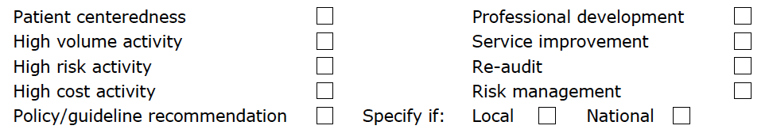

Against which standards are you auditing?

e.g. RCN Competencies/NICE Guidelines/CPSA Standards/independent organisation standards/your own standards.

List or attach the standards/criteria against which you are assessing/auditing the clinical practice.

The following is an example of an audit of a Consultation, Agreement and Consent Document.

CLIENT CONSULTATION, AGREEMENT AND CONSENT

- A consultation documentation needs to record details of the client’s health and general wellbeing, lifestyle choices and any current medication being taken. Check that these questions are included in your document.

- Is the treatment medically suitable for the client? Have all contra-indications been assessed?  If not included, detail the omissions and actions to be taken. | Y/N
- Is there a need for a medical referral?  If not included, detail the omissions and actions to be taken. | Y/N
- Are there any medically related restrictions? Are any adaptations needed to the treatment?  If not included, detail the omissions and actions to be taken. | Y/N
- What is the client’s motivation for the treatment? Are there any psychological/social issues?  If not included, detail the omissions and actions to be taken. | Y/N
- A consultation document needs to result in an accurate assessment of the current influences on the client’s skin health. These might include the following. Check that your document includes them.

- Are there any environmental influences?  If not included, detail the omissions and actions to be taken. | Y/N
- Are there any age-related influences?  If not included, detail the omissions and actions to be taken. | Y/N
- Are there any occupational Influences?  If not included, detail the omissions and actions to be taken. | Y/N
- Are there any lifestyle Influences?  If not included, detail the omissions and actions to be taken. | Y/N
- Are there any nutritional Influences?  If not included, detail the omissions and actions to be taken. | Y/N

- Are there any general health influences or medication?  If not included, detail the omissions and actions to be taken. | Y/N
- Are there any other specific Influences concerning skin health?  If not included, detail the omissions and actions to be taken. | Y/N
3. The consent documentation must be compliant with legal insurance requirements and must be worded accordingly. Check that the following consent/agreement statements are included in your document.

- detailed treatment information to be given to the client, including explanations of the treatment procedure, sensations, side-effects, potential risks and aftercare.  If not included, detail the omissions and actions to be taken. | Y/N
- client’s consent in terms of the full disclosure of information. This is to be signed and dated by the client.  If not included, detail the omissions and actions to be taken. | Y/N
- client’s consent/agreement in terms of their full understanding of the treatment procedure and any side effects, risks or adverse events that may occur. This is to be signed and dated by the client.  If not included, detail the omissions and actions to be taken. | Y/N
- client’s consent to clinical photographs being  taken and used as part of the treatment. This to be signed and dated by the client.  If not included, detail the omissions and actions to be taken. | Y/N
- Includes client consent to the treatment/procedure. This is to be signed and dated by the client.  If not included, detail the omissions and actions to be taken. | Y/N

SUMMARY OF ACTIONS TO TAKEN

TARGET DATE FOR COMPLETION OF ACTION PLAN

AUDIT REPORT SUPPLIED TO : (List of Stakeholders/Staff Members )

Auditors Signature …………………………………………

Print Name …………………………………………………….

Date ………………………

