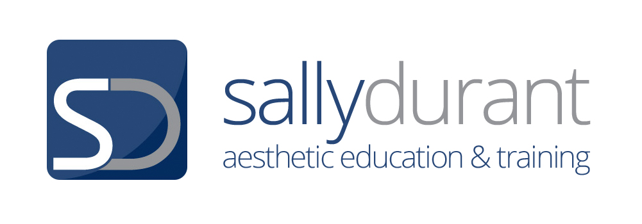

Chemical Peeling Summary Sheet

Be ready ….
Make sure you have everything you need for the treatment- Brand specific products can be selected later but not general items.
Timer, Vaseline, Applicators/ brushes, bowls, cold water and removal gauzes etc
Make sure all bottles are open and are working eg neutraliser sprays

Carry out….
Consultation, Treatment explanations & gain consent for treatment & photos.
Be thinking about your peel choice & make suggestions at this stage.

Give instruction clearly for removal of clothing and assist to the couch
Remember modesty & put clothes tidy and all shoes, jewellery etc under the bed
Cover the client with the towels and place a tissue over the small towel at the top. Put the client chair under the bottom of the bed.

Hair protection
Boudoir cap and disposable band- band to go over the head first- cap on- lift band back to cover the edge of the cap. Place a rolled up towel at the back of the neck to ensure the client does not get too wet if you need to use lots of water

Wash hands and apply alcohol hand gel

Superficial & Double Cleanse
Use the cleanser that is appropriate for the peel you are thinking you will use. No gloves required. Feel the skin.
Medik8 Gentle cleanse / red alert or beta cleanse if an oily skin
Neostrata use the Facial Cleanser
Mesoestetic Hydra milk cleaner

Skin analysis
Under the mag lamp to ensure the treatment is safe to go ahead and to make sure you can select your peel properly.
Is the peel choice you had thought about at consultation still appropriate now you have looked at the skin, still good choice or do you need to change?

Photos
Sit the client up and head lifted not laid back on the couch
Place lamp directly in front of the client
Take front view photo about 12 inches away
Move the lamp to the side so there are no shadows and take the photo- repeat on both sides. , Take a close up of any areas of particular concern

Lie the client back down & Check the hair protection

Wash hands

PEEL FORMULATIONS
MEDIK8 | NEOSTRATA | MESOESTETIC
MEDIK8 LIGHT PEEL  Superficial Level 1  Gel Peel  17.4 % pH 2.8  Ingredients  8%L-Mandelic acid, 7% L-Lactic acid, 2% Salicylic & 0.47% Lactobionic acid.  MEDIK8 COMBINATION PEELS  SUPERFICIAL LEVEL 2  GEL PEELS  1. Age Peel - 49%  pH 2.2  20% L-Mandelic  18% L-Lactic  10% Salicylic  1% Lactobionic  2. Beta eel - 47%  pH 2.2  18% L-Lactic  14% Salicylic  10% Azalaic  5% L-Mandelic  3. White Peel 46%  pH 2.2  23% L-Lactic  10% L-Mandelic  10% Salicylic  3% Phytic | NON BUFFERED GLYCOLIC  Liquid Peels  20% Glycolic 1.6pH  35% Glycolic 1.3 pH  30% Clarifying Peel  1.6pH  Mandelic and Citric acid  Can be used on its own or underneath a glycolic  30% Brightening Peel  1.6pH  Citric acid  Can be used on its own or underneath a glycolic | SINGLE AGENT  Gel Peels  ALL pH 1.8  1. Glycolic 20% / 35%  2. Lactic 30% / 40%  3. Salicylic 10% / 20%  4. Mandelic 30% / 40%  COMBINATION  Liquid Peels  1. Mesopeel Melanostop  0.9 pH  20% Azaleic acid with 10% Resorcinol and  6% Phytic acid  2. Mesopeel Azelan  1.5pH  20% Azelaic and  20% Salicylic  3. Mesopeel Jessner  14% Salicylic  14% Lactic  8% Citric  pH 1.5
PEEL PROCEDURE STEPS FOR EACH BRAND

MEDIK8
- Cleanse x2 with a medik8 foam cleanser

- Skin Analysis

- Take pre treatment photo

- De grease with pre peel. (acetone & alcohol) Strong-Use on damp pads to dilute a little. Get the client to breathe in as you apply to the nose and lower face - a systematic firm wipe over the face- Do not keep wiping haphazardly

- Vaseline protection to all taught areas & use eye pads. Make sure the eye pads are lightly damp and that they create a seal around the eye properly. (Note eye pads that are too wet may lead to the peel reacting with the water in the eye pad- this must not happen)

- Pour peel into ceramic dish. Use all of the small bottle

- Set Timer – 4 mins is an average time. 1-4 mins first time. Could be left up to 10 mins.

- Apply the peel. Best applied with a brush.

- Apply quickly (aim for 30-40 seconds), systematically- Top to bottom but moving from one side of the face to the other as you move down to the chin. Under eyes and lips the last place to apply.

- Watch and listen to your client. Assess their tolerance level- 1-10 & skin reaction

- Expect erythema and sometimes mild opaque frosting- expect heat and tingling

- Respond quickly if you get any areas of frosting- assess and remove

- Neutralise- Spray 12 inches away all over face – Heat will rise. Warn client- this is the skin recognising the pH alteration not a reactivation of the peel

- Remove neutraliser quickly- and cool the skin with wet gauzes

- Step 1- Wipe the gauzes over all the face and then throw away, repeat and throw away

- Step 2- Place cold gauzes all over the face to make compress pads. Keep placing back into the cold water & replacing onto the skin. Or apply to the skin and simply press into the skin to cool.

- Continue until the skin is back to normal. Sensation level 1-2.

- Pat dry

- Apply a gauze with Hydr8 B5 and C tetra Vit C Antioxidant and leave for 10 mins. Complete paperwork during this time.

- Start to discuss after care whilst removing gauze mask

- Apply physical SPF.

- Sit the client up and Take photo and Remove hair protection

- Complete all documentation – client to sign to say they are happy & any thing else you have not done and escort your client out of the treatment room

NEOSTRATA
- Cleanse x 2 with Neostrata facial cleanser

- Skin Analysis

- Take pre treatment photo

- De-grease with balancing pre peel cleanser. This is not as pungent as Medik8. An alcohol based de-greaser

- Apply with a systematic firm wipe over the face from top to bottom- Do not keep wiping haphazardly

- Vaseline protection to all taught areas & use eye pads. Make sure the eye pads are lightly damp and that they create a seal around the eye properly. (Note eye pads that are too wet may lead to the peel reacting with the water in the eye pad- this must not happen)

- Pour about 2.5 ml (1tsp) of peel into ceramic dish.

- Set Timer – 4 mins is an average time you can go to 5 minute with a glycolic. 1-4 first time

- Apply the peel. Best applied with a brush or glycolic applicator.

When layering the glycolic peel with either the clarifying or brightening peel apply as below-

For 2 minutes apply clarifying or brightening peel and then follow with the glycolic peel for a further 4-5 minutes- A total of 7 minutes maximum.

- Apply quickly (aim for 30-40 seconds), firmly and systematically- Top to bottom but moving from one side of the face to the other as you move down to the chin. Under eyes and lips the last place to apply.

- Watch and listen to your client. Assess their tolerance level- 1-10 & skin reaction. Above 7 neutralise and remove.

- Expect erythema, frosting unlikely. Not much heat but itchy and prickling

- Neutralise- Act Quickly - Spray all over face a section at a time at a close distance. Foaming will occur when the peel is still active. Use a cotton pad to mop up as you work. Intense heat is unlikely.

- Remove neutraliser and cool the skin with wet gauzes quickly

Wipe the gauzes over all the face and then throw away, repeat and throw away
place cold gauzes all over the face to make compress pads. Keep placing back into the cold water & replacing onto the skin.

- Continue until the skin is back to normal. Bring the skin back to 1-2 sensation

- Pat dry

- Create a mask with a blend of two serums and place damp gauzes over the face for 10 mins – Antioxidant, bionic, firming. Complete documentation

- Start to discuss after care whilst removing gauze mask

- Apply Day Time Protection Cream and/or Sheer Physical Protection 50

- Sit the client up and take photo

- Remove hair protection, complete all documentation and escort your client out

MESOESTETIC
- Cleanse x2 with Hydra Milk cleanser & tone with Hydratonic

- Skin Analysis

- Take pre treatment photo

- De-grease with pre-procedure cleansing solution. A Hydroxy acid based degreaser -glycolic acid, lactic acid, salicylic acid, lactobionic acid, alpha bisabolol and has a pH of 4.5. Not pungent.

- Use a Rough gauze 2x2cm size, Wet but not dripping. Fold into a triangle or square and using your thumb or fingers apply firm pressure. Rub very firmly over the face starting at the forehead. And moving systematically down the face from side to side. You can do outward movements and support the skin as you work. Expect to see erythema

- Vaseline or Mesolips protection to all taught areas & use eye pads. Make sure the eye pads are lightly damp and that they create a seal around the eye properly. (Note eye pads that are too wet may lead to the peel reacting with the water in the eye pad- this must not happen)

- For single agent gel peels : Pour about 3mls of the peel into the measuring vessel. Set timer 5 mins is an average time. 1-4 first time. Could go up to 10 for all first level peels

Apply the peel. Best applied with a brush

- For combination liquid peels : Pour about 3mls of the peel into the measuring vessel.
Set timer 5 mins is an average time. 1-4 mins first time

Apply the peel. Best applied with rough gauze.

- Apply quickly (aim for 30-40 seconds), Very firmly and systematically- Top to bottom but moving from one side of the face to the other as you move down to the chin. Under eyes and lips the last place to apply.

- Watch and listen to your client. Assess their tolerance level- 1-10 & skin reaction

- Expect erythema, frosting unlikely. Not much heat but a gentle prickling

- React quickly

- Neutralise step 1 - Using cold, nicely dampened gauzes, wash the treated area 3 times starting with the centre and cheeks and finishing with the forehead.

Neutralise step 2 - Spray with neutralizing spray all over. The sensation may rise but equally many will feel a calming effect. This is not wiped off at this stage when using Mesoestetic peels

- Apply crystal fibre mask to the skin and leave for 10 minutes

- Remove the mask and wipe the skin with dampened gauzes.

- Start to discuss after care whilst removing mask

- Apply & massage in Post Procedure Fast Skin Repair until absorbed and then SPF 50 moisturising sun protection

- Sit the client up and Take photo

- Remove hair protection, complete all documentation and escort your client from the treatment room

