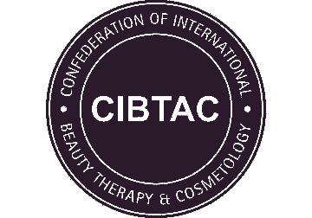
PORTFOLIO CHECKLIST
CSDA02 Level 4 Award in Advanced Skin Studies

Centre Name
Learner Name
Learner Number

 | Date Completed | Tutor Signature
Core Knowledge
Advanced Skin Science

DECLARATION
I confirm that the evidence provided is as a result of my own work and where necessary any quotes or references have been clearly identified as such.
Signature of Learner |  | Date

