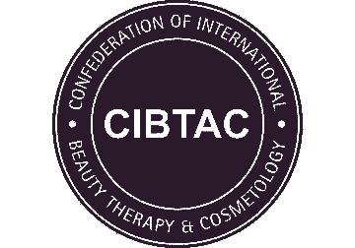
PORTFOLIO CHECKLIST
CSDA03 Level 4 Award in Skin Health Assessment for Aesthetic Practitioners

Centre Name
Learner Name
Learner Number

 | Date Completed | Tutor Signature
Investigative Consultation & Advanced Skin Assessment
Case Studies - Consultation

DECLARATION
I confirm that the evidence provided is as a result of my own work and where necessary any quotes or references have been clearly identified as such.
Signature of Learner |  | Date

