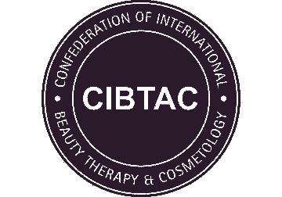
PORTFOLIO CHECKLIST
CSDC02 Level 4 Certificate in Chemical Skin Peel

Centre Name
Learner Name
Learner Number

 | Date Completed | Tutor Signature
Core Knowledge
Chemical Skin Peel
Case Studies: Chemical Skin Peel

DECLARATION
I confirm that the evidence provided is as a result of my own work and where necessary any quotes or references have been clearly identified as such.
Signature of Learner |  | Date

