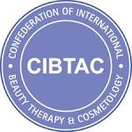
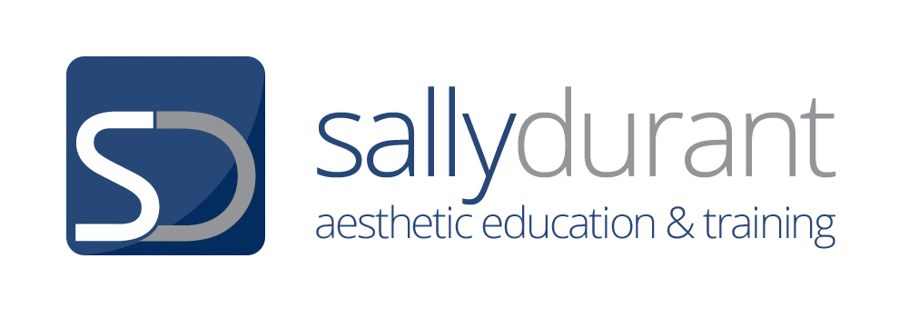

COURSE MARKING SHEET
UNIT SDTO3 L4 INVESTIGATIVE CONSULTATION & ADVANCED SKIN ASSESSMENT

Use this document alongside the assessment workbook / portfolio to determine if the learner has covered all the required learning outcomes to the required standard. This is a knowledge only course.

Candidate Name |  | CIBTAC/SDTC Registration Number
Date of Assessment workbook/ portfolio Marking |  | MCQ’s Completed & Passed (See MCQ Log)  Assessor must sign to indicate they are completed & passed.
Course Completion Date

Learning outcomes 1- 3.1 are evidenced through the completion of the course manual, the course assessment workbook, the internal MCQ’s, internal practical assessment and the external MCQ exam.

Learning Outcome | Assessment Criteria/Objective | Outcome | Referrals- If this column is ticked you will need to refer to the comments inside workbook for specific details – You will need to add to your work and re-submit
1.  Understand investigative consultation and advanced skin assessment and contextualise the importance to aesthetic treatment | 1.1  State the meaning of the terms investigative consultation and advanced skin assessment | Pass  ✓ | Referral
 | 1.2  Explain the requirements of the Data Protection Act 1998 as it relates to clinical aesthetics practice | Pass  ✓ | Referral
 | 1.3  Explain the preparations required for Investigative Consultation and Advanced Skin Assessment | Pass  ✓ | Referral
 | 1.4  Evaluate the consultation and assessment documentation and analyse what can be deduced from a thorough interpretation of client personal information. | Pass  ✓ | Referral
 | 1.5  Explain free radicals, free radical damage in the skin and the effects of antioxidants. | Pass  ✓ | Referral
 | 1.6  Analyse the questions required for a thorough investigative consultation of lifestyle influences on the skin | Pass  ✓ | Referral
 | 1.7 Consider the questions required for a thorough investigative consultation of medical history and general health for establishing the consultation outcome and likely treatment outcome | Pass  ✓ | Referral
2. Understand the primary skin types and secondary skin conditions and the methods of advanced skin assessment | 2.1  Evaluate the causes, characteristics and needs of the five primary skin types | Pass  ✓ | Referral
 | 2.2  Evaluate the causes, characteristics and needs of the secondary skin conditions | Pass  ✓ | Referral
 | 2.3  Explain the manual methods of assessment that can be used to ascertain skin condition | Pass  ✓ | Referral
 | 2.4  Explain the visual characteristics and physiological alterations associated with skin ageing and imbalance | Pass  ✓ | Referral
 | 2.5  Analyse the use of advanced skin assessment equipment and classification scales | Pass  ✓ | Referral
3.  Carry out investigative consultation and advanced skin assessment and reflect and contextualise the information to devise safe, effective and ethical skin treatment programmes | 3.1  Carry out investigative consultation and advanced skin assessment, evaluate the client information and devise appropriate skin treatment programmes | Pass  ✓ | Referral

Assessor Comments | Well done (insert learner name) . You have now completed the internal assessment requirements for the Unit SDT03 Level 4 Investigative Consultation and Skin Assessment unit as indicated below.  See the table below for full information about the course requirements  Course Assessment Protocol for  Unit SDT03 Level 4 Investigative Consultation and Advanced skin Assessment  Assessment Type Result  1. Internal assessment  Course presentations- Will all need to have been accessed and worked through  Modular MCQs- will all need to be passed at a minimum of 70%  Course Workbook and case study evidence from module 7 will need to have been marked as sufficient for a pass mark  Practical Assessment  You will need to have attended the practical day and have collated documented evidence to show a pass grade  2. External Assessment  MCQ Examination at your delivering centre This exam will be graded. 85% Distinction 75% Credit 60% Pass 59% and below fail CIBTAC will notify the delivering centre of results and you will then be notified from your particular centre  Presentation of your work  The external CIBTAC examiner will need to see all your work.  1. Your course Workbook- This may be presented in hard copy or electronic form  3. Evidence of passed MCQs with grades - This will be presented in electronic form  Assessor comments  Internal Assessment Evidence  1. Modular MCQs  The MCQ’s were mostly completed well/ excellently /well. Well done.  2. Course Workbook  Your work is reflective of some/ a great deal of hard work and effort clearly demonstrating some/ good/ excellent commitment and dedication to your learning and the Course itself.  Your answers are sufficient/good/excellent reflecting sufficient/good/excellent understanding of the key concepts both from a theoretical and a practical perspective. You have made a sufficient/good/excellent effort to learn everything possible from the Audio presentations and have been able to include some/many detailed discussions and visuals ensuring that you have a useful resource to look back on. You have also included some/good/excellent excellent additional research.  3. Practical Assessment  The practical Assessment documentation shows you to be a very competent practitioner with sufficient/good/excellent skills of consultation and skin evaluation along with professional, effective and safe practice skills. Well done.  You may also want to add a comments/s that relates specifically to the person  The External Assessment  1. You will need to attend your delivering centre to take an end of course exam- This exam will consist of a Multiple Choice Question Paper that will reflect the total content of your elected course. This test paper will be graded. Pass, Credit OR Distinction.  2. You will need to present all your passed internal course assessment to the CIBTAC examiner. This will be done at the end external examination.  It is your responsibility to make sure you have all your course assessment evidence for the examiner.  Exam Results  Results will be sent from CIBTAC 6 weeks after the exam date to your delivering centre. You will then be notified.  CIBTAC/SDTC Certification  Certification will be realised when you have completed and passed the external MCQ examination and had all your internal assessment evidence checked by the CIBTAC external examiner.  Letters of Achievement  Your delivering centre may be able to provide you a letter of part achievement in the interim if you should need it. Please contact your tutor for details on how to do this.  Your Course Manuals & Assessment Evidence  Important note- You should note that employers, other educational establishments, registering bodies and insurers may want evidence of your learning at some point in the future. Your completed assessment evidence along with your course manual and your qualification certificate, will provide you with all the evidence you may need. Keep all your work secure and in good order.  Final Tutor Comments  I would like to take this opportunity to say well done and it has been a pleasure being your tutor.  Further Advice  Just in case you are not fully aware of the recent sector changes- There has been a new registering body set up for aesthetic practitioners following the HEE recommendations of January 2016 and the more recent DoH interventions. This body is the ‘Joint Council for Cosmetic Practitioners’ (JCCP).  It will mean that for the first time both medical and non-medical practitioners carrying out aesthetic treatments will have an official registering authority. Practitioners from the Beauty therapy sector will have to have minimum of accredited level 4, sector related qualifications, in addition to any skill specific manufacturer led training they may have, to gain access to the register and medical practitioners will have to verify their medical qualification in addition to any skill specific manufacturer led training.  This is really exciting and a significant step forward for all practitioners. It will go a long way to ensuring protection of the public and in addition the future of all practitioners in the sector, regardless of background. We expect this body to become more evident in the next year and significantly so over the next few years.
Assessor Name | Assessor Signature

