THE CIBTAC / SALLY DURANT
QUALIFICATION PORTFOLIO

Level 3 Anatomy & Physiology

MODULE 2

ASSESSMENT WORKBOOK
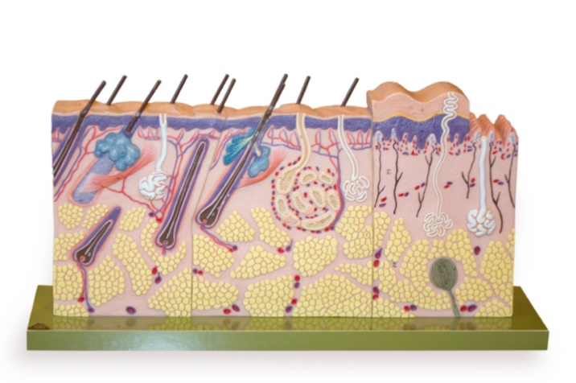

DELEGATE NAME

CIBTAC REGISTRATION NUMBER

LEVEL 3 ANATOMY AND PHYSIOLOGY

MODULE 2 THE INTEGUMENTARY SYSTEM - ASSESSMENT WORKBOOK

Write your answers in the table below. The spacing will expand as you type.

LEARNING OBJECTIVE

2.1 to explain the structure, function, growth and repair of the integumentary system

QUESTION L3 A&P M2/01

In your own words, explain the basic structure and function of the layers of the epidermis.

YOUR ANSWER  - stratum germinativum  - stratum spinosum (Malpighian layer)  - stratum granulosum  - stratum lucidum  - stratum corneum | TUTOR COMMENT

QUESTION L3 A&P M2/02

In your own words describe the component parts of the extra cellular matrix of the dermis.

YOUR ANSWER  - collagen  - elastin  - hyaluronic acid | TUTOR COMMENTS

QUESTION L3 A&P M2/03

In your own words explain the function of the skin using the mnemonic SHAPES + V

YOUR ANSWER  - S  - H  - A  - P  - E  - S  - + V | TUTOR COMMENTS

LEARNING OBJECTIVE

2.2 to describe the main diseases and disorders of the skin

QUESTION L3 A&P M2/04

Using your notes, textbooks and internet sources, write notes to explain (in your own words) the causes and symptoms of the following diseases and disorders of the skin.

- scabies  - impetigo  - eczema  - psoriasis  - warts/verrucae  - herpes (zoster and simplex)  - tinea (corporis, pedis, and capitis)  - pityriasis versicolor  - malaria rubra  - dermatosis papulosa nigra | TUTOR COMMENTS

You have now completed the Level 3 Anatomy and Physiology Workbook for Module 2.

Check your work thoroughly and then email it in Word format to marking@sallydurant.com

FOR TUTOR COMPLETION ONLY

Result:

Comment:

Areas of referral:

Action to be taken:

Date for resubmission:

Tutor Signature:
Name:

Date work marked:

Date work retuned:

