LEVEL 3 ANATOMY AND PHYSIOLOGY

MODULE 10 SECTION 1

THE DIGESTIVE SYSTEM

ASSESSMENT WORKBOOK
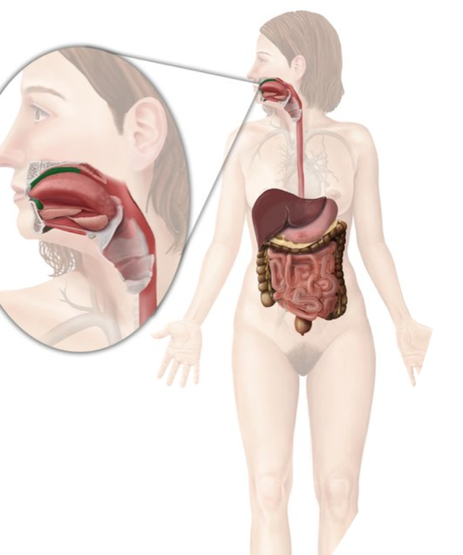

DELEGATE NAME

CIBTAC REGISTRATION NUMBER

LEVEL 3 ANATOMY AND PHYSIOLOGY - MODULE 10 THE DIGESTIVE SYSTEM
ASSESSMENT WORKBOOK
Write your answers in the table below. The spacing will expand as you type.

LEARNING OBJECTIVE

10.1 to explain the structure and function of the digestive system

QUESTION L3 A&P M10/01

List the organs, and accessory organs, of the digestive system and explain their function.

YOUR ANSWER | TUTOR COMMENT
QUESTION L3 A&P M10/02

In your own words, explain the following terms.

YOUR ANSWER  - Mastication  - Epiglottis  - Peristalsis  - Bolus  - Lower Oesophageal Sphincter  - Pyloric Sphincter  - Hydrochloric Acid  - Enzyme  - Chyme  - Bile  - Villi  - Ileo-caecal Valve  - Appendix | TUTOR COMMENTS

LEARNING OBJECTIVE

10.2 to explain the process of digestion

QUESTION L3 A&P M10/03

In your own words, describe the mechanical and chemical processes of digestion which occur in each part of the digestive tract listed below. Include the specific chemicals and enzymes secreted at each stage and explain their action.

YOUR ANSWER  - The Buccal Cavity  - Enzymes and Action  - The Oropharynx and Oesophagus  - The Stomach  - Digestive Juices/Enzymes and Action  - The Duodenum, Jejunum and Ileum  - Digestive Juices/Enzymes and Action  - The Colon | TUTOR COMMENTS

QUESTION L3 A&P M10/04

In your own words, explain how digested food and nutrients are absorbed by the villi in the small intestine. Your answer must include detail of the end-products from the digestion of protein, fat and carbohydrates. You should also explain how vitamins and minerals are absorbed and distributed around the body

- The end-products of carbohydrates  - The end-products of protein  - The end-products of fat  - The end-products of vitamins and minerals  - Water | TUTOR COMMENTS

LEARNING OBJECTIVE

10.2 to describe the dietary nutrients required for growth and repair and to show understanding of their role in the body and in the maintenance of health.

QUESTION L3 A&P M10/05

The essential components of a healthy diet are listed below. Describe the function of each one and give examples of its sources in food.

- Carbohydrates  - Protein  - Fats and oils  - Fibre  - Water | TUTOR COMMENTS

QUESTION L3 A&P M10/05

Complete the chart below, adding in the sources and function of each vitamin and mineral.

Name | Sources | Function
Vitamin A

Vitamin B Group

Vitamin C

Vitamin D

Vitamin E

Vitamin K

Sodium

Calcium

Iron

Potassium

Zinc

Selenium

Magnesium

Phosphorous

QUESTION L3 A&P M10/06

Using your existing knowledge, textbooks and the internet, describe the diseases and disorders of the digestive system listed below. Include the main causes and symptoms.

- Appendicitis  - Cirrhosis of the Liver  - Jaundice  - Heartburn  - Irritable Bowel Syndrome (IBS)  - Ulcer (e.g. stomach or duodenal)  - Hernia  - Anorexia Nervosa  - Bulimia Nervosa  - Constipation  - Gallstones  - Diabetes Mellitus  - Diabetes Insipidus  - Celiac Disease | TUTOR COMMENTS

QUESTION L3 A&P M10/07

Using the resources available to you, research each of the diseases and disorders listed below. Explain which dietary nutrients are deficient and the symptoms of each condition.

YOUR ANSWER  - Scurvy  - Iron Deficiency (Anaemia)  - Pernicious Anaemia  - Rickets  - Pellagra  - Goitre  - Beriberi  - Xeropthalmia  - Dehydration  - Muscle Cramps  - Ketosis  - Weak Bones | TUTOR COMMENTS

QUESTION L3 A&P M10/08

Using the resources available to you, research the detriment to health caused by excess dietary intake of each of the given nutrients.

- Vitamin A  - Vitamin D  - Vitamin K  - Sodium Chloride (Common Salt)  - Calcium  - Saturated Fat | TUTOR COMMENTS

You have now completed the Assessment Workbook for Level 3 Anatomy and Physiology Module 10.

Check your work thoroughly and then email it in WORD format to marking@sallydurant.com

FOR TUTOR COMPLETION ONLY

Overall Pass: Y / N

Areas of referral:

Actions to be taken:

Date for resubmission:

Tutor Signature:

Name:

Date work marked:

Date work returned:

