LEVEL 3 ANATOMY AND PHYSIOLOGY

MODULE 3 THE SKELETAL SYSTEM

ASSESSMENT WORKBOOK

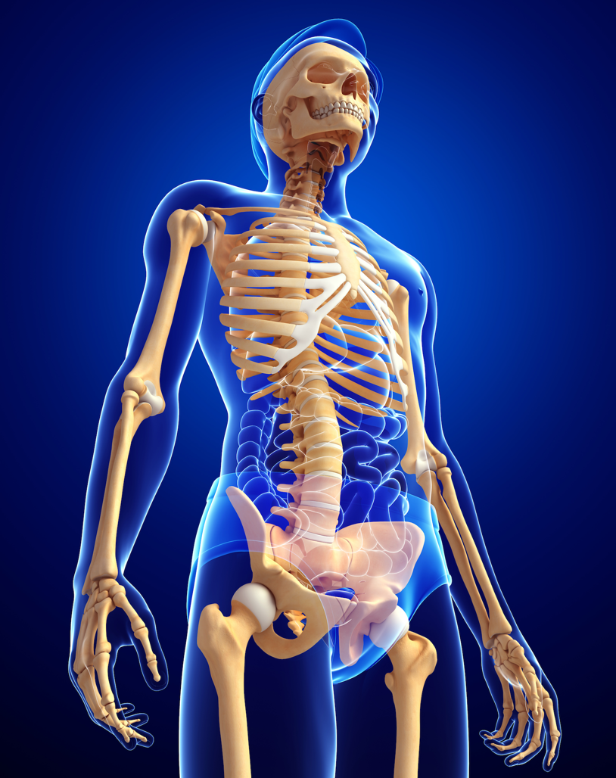

DELEGATE NAME

CIBTAC REGISTRATION NUMBER

LEVEL 3 ANATOMY AND PHYSIOLOGY

MODULE 3 THE SKELETAL SYSTEM

ASSESSMENT WORKBOOK

Enter your answers into the table below. The spacing will expand as you type.

LEARNING OBJECTIVE

3.2 Explain the structure, function and growth of the skeletal system.

QUESTION L3 - A/P – M3/01
In your own words, write an explanation of the structure of bone tissue. Use the headings given below.

YOUR ANSWER  - The Nature of Bone as a Living Tissue  - The 4 Types of Bone Cells  - The Structure of an Osteon  - Compact Bone  - Cancellous Bone | TUTOR COMMENT
QUESTION L3 - A/P – M3/02
In your own words, describe the 5 different types of bone and give examples of where they are found in the body.

YOUR ANSWER  - Long Bones  - Short Bones  - Flat Bones  - Irregular Bones | TUTOR COMMENTS
LEARNING OBJECTIVE
3.3 Explain the types of joints and their range of movement.

QUESTION - L3 - A/P – M3/03
In your own words, describe the different types of joints in the body. State clearly what type of movement they facilitate and give examples of where they can be found in the human body.

YOUR ANSWER

- Fixed Joints

- Cartilaginous Joints

- Synovial Joints
- Hinge Joints

- Pivot Joints

- Gliding Joints

- Saddle Joints

- Condyloid joints

- Ball and Socket Joint

QUESTION – L3 – A/P – M3/04

Use your notes, textbooks and internet sources, to research and write notes explaining the meaning of the following anatomical directional terms. You must use your own words wherever possible.

QUESTION L3 - A/P – M3/04

- Medial

- Lateral

- Ipsilateral

- Contralateral

- Superior

- Caudal or Inferior

- Anterior or Ventral

- Posterior or Dorsal

- Proximal

- Distal

- Parietal

- Visceral

LEARNING OBJECTIVE
3.5 Describe the main diseases and disorders of the skeletal system

QUESTION L3 – A/P - M3/05

Using your notes, textbooks, internet sources and research, write notes to explain (in your own words) the causes and symptoms of the following diseases and disorders of the skeletal system.

- Osteoarthritis

- Rheumatoid Arthritis

- Gout

- Osteoporosis

- Stress Fractures

You have now completed the Level 3 Anatomy and Physiology Workbook for this Module.

Check your work thoroughly and then email it in Word format to marking@sallydurant.com

ONLY FOR COMPLETION BY A TUTOR

Overall Pass Y / N
Areas of referral/action to be taken
New submission date
Tutor Name
Signature
Date work marked
Date work returned

