LEVEL 3 ANATOMY AND PHYSIOLOGY

MODULE 5 THE CARDIOVASCULAR SYSTEM

ASSESSMENT WORKBOOK

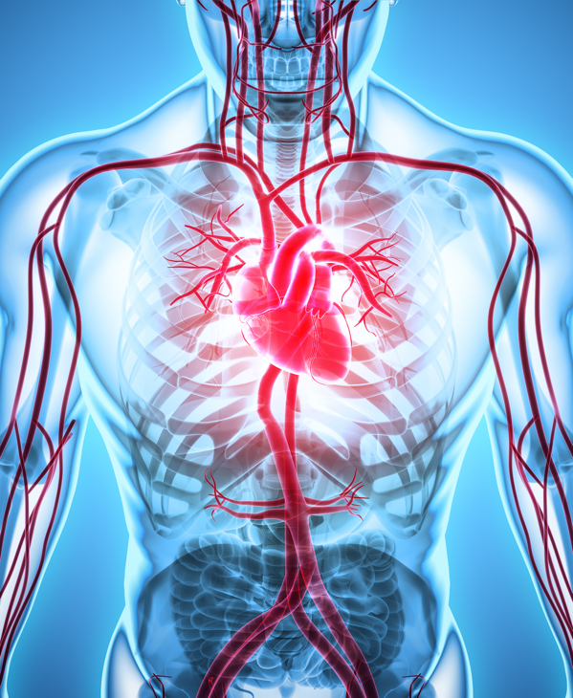

DELEGATE NAME

CIBTAC REGISTRATION NUMBER

LEVEL 3 ANATOMY AND PHYSIOLOGY

MODULE 5 THE CARDIOVASCULAR SYSTEM

ASSESSMENT WORKBOOK

Write your answers in the table below. The spacing will expand as you type.

LEARNING OBJECTIVES
6.1 to explain the structure and function of the cardiovascular system
6.3 to explain the location, structure and function of the heart
6.4 to explain the types of blood vessels

QUESTION L3 A&P M5/01
In your own words, explain the location and structure of the heart. Follow the subheadings provided below.

YOUR ANSWER  - The Location of the Heart  - The Chambers of the Heart  - The Valves of the Heart  - The Walls of the Heart  - The Septum of the Heart | TUTOR COMMENT
QUESTION L3 A&P M5/02

In your own words, explain the systemic circulation from the left atrium of the heart to the stomach and back to the right atrium of the heart. You must give the names of the structures and vessels through which the blood passes, and state whether, at each stage, the blood is oxygenated or deoxygenated.

You may use a bullet point system to describe this process if you prefer. Some bullet points have been provided for you, but this does not indicate the number of points there should be in the answer.

YOUR ANSWER | TUTOR COMMENTS
QUESTION L3 A&P M5/03
In your own words, In your own words, explain the pulmonary circulation from the right atrium of the heart to the lungs and back to the left atrium of the heart. You must give the names of the structures and vessels through which the blood passes, and state whether, at each stage, the blood is oxygenated or deoxygenated.

You may use a bullet point system to describe this process if you prefer. Some bullet points have been provided for you, but this does not indicate the number of points there should be in the answer.

YOUR ANSWER

LEARNING OBJECTIVE
6.5 to identify the major blood vessels of the head and upper body

QUESTION L3 A&P M5/04
The following main arteries and veins supply blood or remove blood from which organs or areas of the body?
YOUR ANSWER

- internal carotid artery
- external carotid artery
- internal jugular vein
- external jugular vein
- coronary artery and vein
- right and left subclavian arteries and veins
- pulmonary artery and vein
- axillary artery and vein
- brachial artery and vein
- radial artery and vein
- gastric artery and vein
- mesenteric artery and vein
- splenic artery and vein
- iliac artery and vein
- femoral artery and vein
- tibial arteries and veins

LEARNING OBJECTIVE
6.7 to describe the main diseases and disorders of the cardiovascular system

QUESTION L3 A&P M5/05

Using your notes, textbooks and internet sources, write notes to explain (in your own words) the causes and symptoms of the following diseases and disorders of the cardiovascular system.

- iron deficiency anaemia

- pernicious anaemia

- varicose veins

- haemophilia

- arteriosclerosis/atherosclerosis

- HIV and AIDS

- high blood pressure (hypertension)

- low blood pressure (hypotension)

- high cholesterol

- hepatitis A, B and C

- coronary thrombosis

- septicaemia

- haemorrhoids

- phlebitis

- thrombus

- embolism

- pulmonary embolism

- leukaemia

- aneurism

You have now completed the Level 3 Anatomy and Physiology Workbook for Module 5.

Check your work thoroughly and then email it in Word format to marking@sallydurant.com

FOR TUTOR COMPLETION ONLY

Overall Pass: Y / N

Areas of referral / actions to be taken:

Date for resubmission:

Tutor Signature:

Name :

Date work marked:

Date work returned :

