LEVEL 3 ANATOMY AND PHYSIOLOGY

MODULE 8 THE NERVOUS SYSTEM

ASSESSMENT WORKBOOK

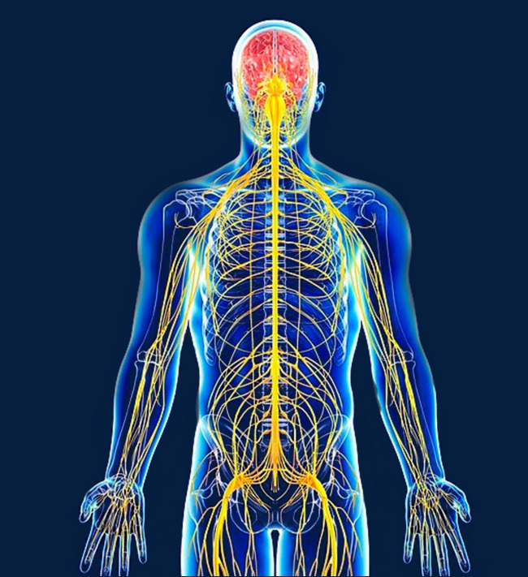

DELEGATE NAME

CIBTAC REGISTRATION NUMBER

LEVEL 3 ANATOMY AND PHYSIOLOGY - MODULE 8 THE NERVOUS SYSTEM

ASSESSMENT WORKBOOK
Write your answers in the table below. The spacing will expand as you type.

LEARNING OBJECTIVES
5.1 to explain the structure and function of the nervous system

QUESTION L3 A&P M8/01
In your own words, BRIEFLY describe the structure and function of the component parts of the nervous system listed below.

YOUR ANSWER  - the central nervous system  - the peripheral nervous system and its sub-categories  - the spinal nerves  - the medulla oblongata  - the pons  - the thalamus  - the hypothalamus  - the cerebellum  - the amygdala  - the corpus callosum  - the meninges | TUTOR COMMENT
QUESTION L3 A&P M8/02
Use bullet points to list the function of each of the lobes of the cerebral cortex.

YOUR ANSWER  - the frontal lobe  - the parietal lobe  - the occipital lobe  - the temporal lobe | TUTOR COMMENTS

QUESTION L3 A&P M8/03
In your own words, describe the structure of a neurone.

YOUR ANSWER

- the cell body

- the dendrites

- the axon

- the myelin sheath

- the synapses

LEARNING OBJECTIVE
5.2 to describe the main diseases and disorders of the nervous system

QUESTION L3 A&P M8/04
Using your notes, textbooks and internet sources, write notes to explain (in your own words) the causes and symptoms of the following diseases and disorders of the nervous system.

- neuritis

- Bell’s palsy

- neuralgia

- Parkinson’s disease

- myalgic encephalomyelitis (ME)

- cerebral palsy

- multiple sclerosis

- sciatica

- motor neurone disease

You have now completed the Level 3 Anatomy and Physiology Workbook Module 8.

Check your work thoroughly and then email it in WORD Format to marking@sallydurant.com.

FOR TUTOR COMPLETION ONLY

Overall Pass Y / N

Areas of referral:

Actions to be taken:

Date for resubmission:

Tutor Signature:

Name:

Date work marked:

Date work returned:

