LEVEL 3 ANATOMY AND PHYSIOLOGY

MODULE 9 THE ENDOCRINE SYSTEM
SECTION 1
ASSESSMENT WORKBOOK
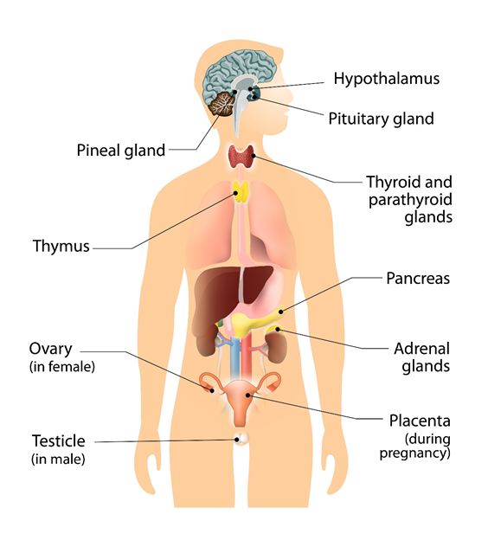

DELEGATE NAME

CIBTAC REGISTRATION NUMBER

LEVEL 3 ANATOMY AND PHYSIOLOGY

MODULE 9 THE ENDOCRINE SYSTEM - ASSESSMENT WORKBOOK

Write your answers in the table below. The spacing will expand as you type.

LEARNING OBJECTIVE

6.1 to explain the structure and function of the endocrine system

QUESTION L3 A&P M9/01

In your own words, give a brief description of the endocrine system including
- the types of glands from which it is formed
- an overview of its function as a whole system

YOUR ANSWER | TUTOR COMMENT

LEARNING OBJECTIVES:

6.2 to explain the location of the endocrine glands
6.3 to explain the function of the endocrine glands
6.4 to describe the hormones secreted from the endocrine glands and their target sites

QUESTION L3 A&P M9/02

In your own words, give the location of each of the endocrine glands below. List the hormones they produce.

YOUR ANSWER  - the anterior lobe of the pituitary gland  - the posterior lobe of the pituitary gland  - the pineal gland  - the thyroid gland  - the parathyroid glands  - the thymus gland  - the pancreas  - the adrenal cortex  - the adrenal medulla  - the testes  - the ovaries | TUTOR COMMENTS

LEARNING OBJECTIVE

6.4 to describe the main diseases and disorders of the endocrine system

QUESTION L3 A&P M4/03

Using your notes, textbooks and internet sources, write notes to explain (in your own words) the causes and symptoms of the following diseases and disorders of the endocrine system.

- Addison’s Syndrome

- Cushing’s Syndrome

- stress

- diabetes insipidus

- diabetes mellitus

You have now completed the Level 3 Anatomy and Physiology Workbook Module 9.

Check your work thoroughly and then email it in WORD Format to marking@sallydurant.com.

FOR TUTOR COMPLETION ONLY

Overall Pass Y / N

Areas of referral:

Actions to be taken:

Date for resubmission:

Tutor Signature:

Name:

Date work marked:

Date returned:

