LEVEL 3 ANATOMY AND PHYSIOLOGY

MODULE 9 SECTION 2

THE REPRODUCTIVE SYSTEM

ASSESSMENT WORKBOOK
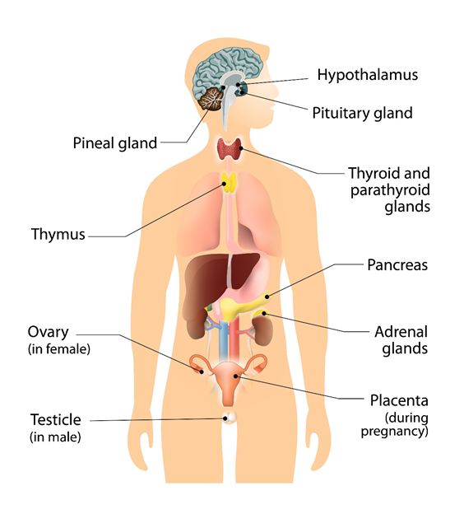

DELEGATE NAME

CIBTAC REGISTRATION NUMBER

LEVEL 3 ANATOMY AND PHYSIOLOGY

MODULE 9 SECTION 2 THE REPRODUCTIVE SYSTEM - ASSESSMENT WORKBOOK

Write your answers in the table below. The spacing will expand as you type.

LEARNING OBJECTIVE

12.1 to explain the structure and function of the reproductive system

QUESTION L3 A&P M9/01

In your own words, give a brief description of the following parts of the male and female reproductive systems.

YOUR ANSWER  Male:  - the testes  - the vas deferens  - the epididymis  - the prostate gland  - the urethra  Female:  - the ovaries  - the ovarian/graafian follicle  - the fallopian tubes  - the uterus  - the endometrium  - the cervix  - the vulva  - the breast | TUTOR COMMENT
LEARNING OBJECTIVE

12.3 to describe the main diseases and disorders of the reproductive system

QUESTION L3 A&P M4/03

Using your notes, textbooks and internet sources, write notes to explain (in your own words) the causes and symptoms of the following diseases and disorders of the reproductive system.

- cancer

- chlamydia,

- ectopic pregnancy

- endometriosis

- fibroids

- hysterectomy

- amenorrhoea

- dysmenorrhoea

- menorrhagia,

- pre-menstrual syndrome

- polycystic ovarian syndrome

- prostatitis

- vulvovaginal candidiasis (thrush)

- bacterial vaginosis

- mastitis

- cysts – breast and ovarian

You have now completed the Level 3 Anatomy and Physiology Workbook Module 9 Section 2.

Check your work thoroughly and then email it in WORD Format to marking@sallydurant.com.

FOR TUTOR COMPLETION ONLY

Overall Pass Y / N

Areas of referral:

Actions to be taken:

Date for resubmission:

Tutor Signature:

Name:

Date work marked:

Date returned:

