LEVEL 3 ANATOMY AND PHYSIOLOGY

MODULE 11 THE URINARY SYSTEM

ASSESSMENT WORKBOOK
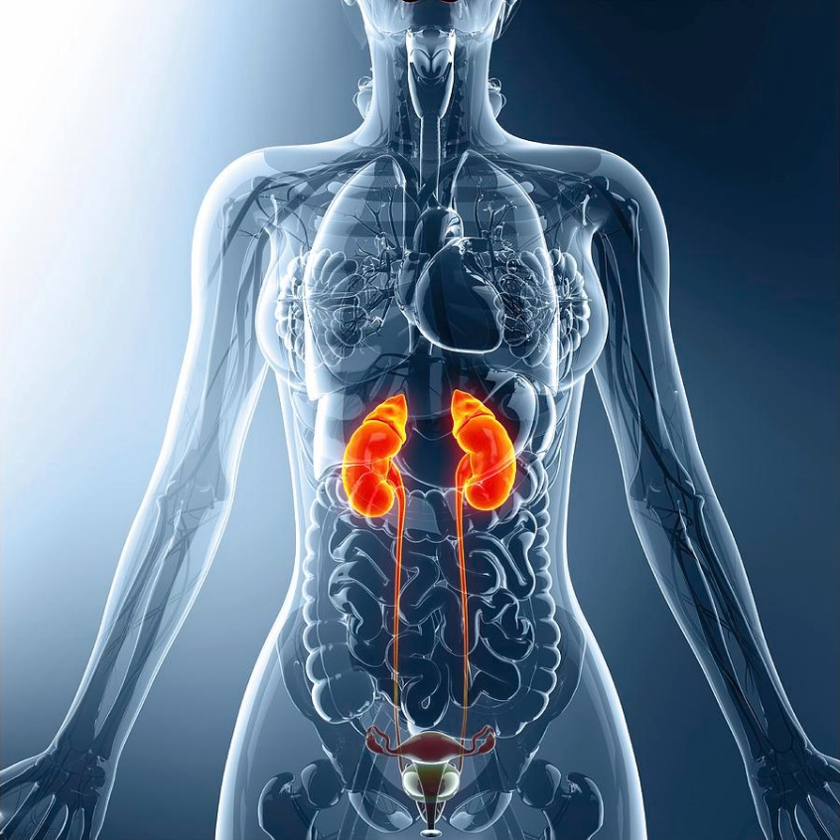

DELEGATE NAME

CIBTAC REGISTRATION NUMBER

LEVEL 3 ANATOMY AND PHYSIOLOGY

MODULE 11 THE URINARY SYSTEM

ASSESSMENT WORKBOOK

Write your answers in the table below. The spacing will expand as you type.

LEARNING OBJECTIVES

7.1 to explain the structure and function of the urinary system
7.2 to explain the production and content of urine

QUESTION L3 A&P M11/01
In your own words, BRIEFLY explain the main features of the structure and function of the following.

YOUR ANSWER  - the renal cortex  - the renal medulla  - the renal pyramids  - the hilum  - the renal pelvis  - the ureter  - the bladder  - the urethra | TUTOR COMMENT

QUESTION L3 A&P M11/02

In your own words, and using the headings below, explain the structure of a kidney nephron. State the principal functions of each part during the processes of filtration, re-absorption and the production of urine.

YOUR ANSWER  - the Bowman’s capsule and glomerulus  - the proximal convoluted tubule  - the loop of Henle  - the distal convoluted tubule  - the collecting duct | TUTOR COMMENTS
LEARNING OBJECTIVE

7.6 to describe the main diseases and disorders of the urinary system

QUESTION L3 A&P M11/03

Using your notes, textbooks and internet sources, write notes to explain, in your own words, the causes and symptoms of the following diseases and disorders of the urinary system.

YOUR ANSWER  - cystitis  - kidney stones  - nephritis | TUTOR COMMENTS

You have now completed the Level 3 Anatomy and Physiology Workbook for Module 11.

Check your work thoroughly and then email it in Word format to marking@sallydurant.com

FOR TUTOR COMPLETION ONLY

Overall Pass: Y / N

Areas of referral:

Action to be taken:

Date for resubmission:

Tutor Signature:

Name:

Date work marked:
Date work returned:

