The CIBTAC / SALLY DURANT
Level 4 Qualifications in Advanced Skin Studies and Aesthetic Practice

STUDENT HANDBOOK

SALLY DURANT CIBTAC, CIDESCO, Cert Ed
Providing Advanced Education and Training to the Medispa Sector

Dear Colleague,

I would like to welcome you to your chosen Level 4 course. My tutors, management staff and myself are fully committed to making your learning with us both an enjoyable experience and a positive step forward in your career progression.

The aesthetic industry has grown immensely over the last twenty years and, thanks to intensive research and development within the sector, we can now access a intricate understanding of the skin, how it functions and how it dysfunctions. We also have a vast array of clinical treatments and sophisticated product formulations which can to provide real results in skin health management and remedial skin treatments for our clients or patients.

Education and training are the key to excellence. If you truly want to be recognised as a specialist in your chosen field you will always be learning – learning from other experts in the sector, from your own research and of course from your own experience.

My Level 4 courses are delivered to you with my personal commitment to give you as much as I can of the knowledge and skills I have accumulated over my 35 years in the beauty therapy and aesthetic industry combined with my experience of many years in developing and delivering formal education and training. My teaching staff have been carefully selected to reflect the same degree of expertise and passion as myself and my management team are determined to ensure that you are looked after during your time with us in the best possible way.

I do hope that you will enjoy your course and that it provides you with the professional development and career opportunities that you aspire to.

I will look forward to monitoring your progress and to meeting you at your practical training

Sally Durant

INTRODUCTION

This Course Handbook has been prepared to provide you with an important guide to the successful completion of your chosen CIBTAC / SALLY DURANT Level 4 qualification.

The confirmation of your understanding and acceptance of the information contained within this Handbook will form the basis of your Learning Agreement. You must therefore read through this document carefully, together with the policies and protocols to which it refers within The Student Zone on our website.

CONTENTS

Course Accreditation ……………………………………………………………... Page 4
The CIBTAC Student Handbook …………………………………………………. Page 4
Your Induction Programme ………………………………………………………. Page 4
Your Course Tutor …………………………………………………………….…….. Page 5
Your Learning Agreement ……………………………………………………….. Page 6
The Unit & Modular Format ………………………………………………………. Page 6
Your Course Completion Schedule …………………………………………….. Page 7
Your Tutorial Schedule …………………………………………………………….. Page 7
The Student Zone …………………………………………………………………… Page 8
Your Course Folders ………………………………………………………………… Page 8
Your SD Memory Stick ……………………………………………………………… Page 9
Your E-Learning Programme ……………………………………………………… Page 9
Internet Bandwidth …………………………………………………………………… Page 9
IT Support ………………………………………………………………………………. Page 10
Completing Your E-Learning ………………………………………………………. Page 10
Booking Your Practical Training………………………………………………………Page 11
Booking Your Unit 7 Workshops & CPD Short Courses …………………………. Page 11
Attending Your Practical Training .. ………………………………………….…… Page 12
Treatment Models ……………………………………………………………………. Page 12
Your Assessment, Assignment & Examination Schedules……………………… Page 13
How To Submit Your Course Work……………………………………………….… Page 17
Your Activity Logs ………………………………………………………………….… Page 18
Building Your Portfolio …………………………………………………………….… Page 19
Your Final CIBTAC Exams …………………………………………………………… Page 20
Useful Contact Information………………………………………………………… Page 22
The Sally Durant Policies and Protocols …………………………………………. Page 23
Log-In Information For The Portal …………………………………………………… Page 39

COURSE ACCREDITATION

The Sally Durant Series of Level 4 courses are accredited by CIBTAC which is one of the most well-established UK International Awarding Bodies specialising in high quality beauty therapy and aesthetic education and training. All our courses sit on the OFQUAL Framework which is the overriding governing body for UK qualifications.

You can view information about these two organisations by going to the websites below:

www.CIBTAC.com

www.gov.uk/government/organisations/ofqual

THE CIBTAC STUDENT HANDBOOK

You can learn all about CIBTAC and their courses in the CIBTAC Student Handbook which also contains a lot of information you may find useful as you progress through your course and prepare to take your exams.

This document is available for you to download from the Sally Durant Student Zone on www.sallydurant.com. Information on the he Student Zone is given later in this Handbook.

YOUR INDUCTION PROGRAMME

If you are enrolled on a Level 4 Certificate or level 4 Diploma it is a mandatory requirement that you attend one of our Induction days. This is to ensure that we can provide you with absolute clarity in regard to how you should compete your course and what is expected of you in relation to your course work, practical training, assessment or assignment completion and examinations schedules.

You will have the opportunity of meeting the key personnel who will be involved in the delivery and management of your course and also have a chance to familiarise yourself with the training environment.

Your course tutor will meet with you and go through your Learning Agreement as well as discussing you intended course Completion Schedule which will help you to plan your studies and practical training within a time frame to suit you. The Induction Day Agenda can be found later on The Student Zone of our website

At your Induction you will be asked to confirm your acceptance of the Sally Durant Policies and Protocols which are designed to provide clarity for our students and to ensure a consistency of standards in your course delivery and completion. Some of these can be found at the back of this handbook but all Policies and Protocols can be found on the Student Zone on our website

YOUR COURSE TUTOR

While the nature of this course is distance learning please never feel that you are on your own! In general terms, your designated course tutor is there to:

- Support, motivate and mentor you throughout your course
- Answer any questions you may have
- Provide learning support for any elements of the course you may find difficult
- Liaise within you on the completion of your course and assessment schedule
- Marking your written assessments, assignments and case studies where applicable
- Arrange your attendance for practical training where applicable
- Assist you in the compilation of your Course Portfolio

Specifically your tutor will:

- Complete your Induction (This is mandatory requirement for all students on our Certificate and Diploma Courses, optional for students completing Awards)
- Complete your Learning Agreement with you
- Liaise with you on your Course Completion Schedule
- Arrange monthly tutorial appointments with you
- Book your practical training days
- Book your Formative Assessment Days
- Book your mock examinations
- Book your final CIBTAC / SALLY DURANT examinations

YOUR COURSE TUTOR’S CONTACT DETAILS

Tutor Name ____________________________________________

Telephone Number ___________________________________________

Email Address ____________________________________________

YOUR LEARNING AGREEMENT

Your course tutor will complete your Learning Agreement with you at you Induction. A copy of this document can be found within the Sally Durant Student zone on our website.

Your Learning Agreement is designed to help you structure your study time and schedule your course completion in a way that fits around the time you have available between your work, family and social commitments. While our emphasis is on flexibility, it will help you to have targets for the achievement of each element of your course. However this is not in any way a binding contract and you can discuss adjustments to you schedules with your course tutor at any time. Therefore you will be advised which examination dates you should aim for and your tutor will provisionally book these for you.

During your Learning Agreement Consultation your tutor will also ensure that you understand what is required of you in the completion of the written elements of your course, how to submit your work for marking and what is expected of you when you sit your examination. All of these elements of you course are covered later in these introductory notes.

At the end of your Learning Agreement you will be asked to sign the most Pertinent Policies and Protocols relevant to your course completion while also being pointed in the direction of all other policies you need to be aware of which are housed within the Student Zone of our website.

THE UNIT AND MODULAR FORMAT OF YOUR COURSE

To provide flexibility for our students and to enable the gradual completion of our qualifications, all of our courses are divided into separate Units of Study. There are seven units currently within our Level 4 Qualifications. These are:

Unit 1 / SDT01 - Core Knowledge for Aesthetic Practice

Unit 2 / SDT02 - Advanced Skin Science

Unit 3 / SDT03 - Investigative Consultation and Advanced Skin Assessment

Unit4 / SDP01 - Provide Chemical Skin Peeling

Unit 5 / SDP02 - Provide Micro-Needling Treatment

Unit 6 / SDP03 - Provide Blemish Removal by Thermolysis and Cryotherapy

Unit 7 / SDT04 - The Principles and practices of the Medispa Sector

Each of these Units are subdivided into smaller modules according to their principle subject matter and each has its own:

- Folder containing a unit-specific guide to your course completion and your course notes
- Section on the E-Learning Platform
- Assessment / Assignment Schedule
- Case study assignment – practical units only.

Please refer to the Qualification and Unit Guide which you will find within our Student Zone on our Website and to the Unit Completion Guide at the front of each of your folders

YOUR COURSE COMPLETION SCHEDULE

As part of your Learning Agreement your course tutor will discuss with you a time scale in which you would like to complete your course and with that in mind they will suggest a schedule for competing each unit of study. This will provide you with set targets for the submission of your coursework and attendance to your practical training.

You are free to set these timescales to suit you and can alter your Course Completion Schedule in line with our Course Completion Policy which you will find later in this handbook and within The Student Zone on our website

YOUR TUTORIAL SCHEDULE

At your induction your Course Tutor will seek to arrange a series of monthly 30 minute appointments when you will be able to discuss your progress and any issues of query or concern that you may have. This will support you in keeping to your Course Completion Schedule

Attendance to your monthly tutorial will be logged and a report will be written by your tutor for insertion into your portfolio. You will also be provided with a Tutorial Log in which you must keep a record of your tutorial discussions for your own reference and to form part of your Course Portfolio.

Of course if you have any need to speak to your Course tutor outside of your monthly appointment you are welcome to do so – they are there to help and support you.

Please note - Our tutors, like you, are extremely busy people and so failure to attend a formal appointment without 24 hours notice will be regarded as being inconsiderate and unprofessional. This will be documented within your Tutorial Log and so reflected in your portfolio.
Please refer to Our Tutorial Policy and Extenuating Circumstances Policy within The Student Zone

THE SALLY DURANT STUDENT ZONE

This is provided to you via our website www.sallydurant.com. You will be provided with a login password to access this. This password will be changed periodically - you will be notified by our administration staff when these changes occur but if you have any issues at any time please contact our admin staff on
01527 919880 or email them at admin@sallydurant.com and they will be happy to provide it to you.

The Student Zone contains additional information and resources that will support you in your course completion. This includes:

- Instructions for access to the E-Learning Portal and completion of your online modules
- The Sally Durant Learning Agreement and Course Schedule templates
- The assessment specification for your chosen course and
- Assignment briefs
- Your course Assessment Workbooks
- Modality specific product / equipment information
- Bibliography, references and other learning resources
- Sally Durant Policies, Procedures and Protocols relating to the delivery, management and completion of your course

YOUR COURSE FOLDERS

Your course folder is your permanent learning resource and contains your course notes, details of how to complete that unit of study and your assessment schedule. The folder is arranged into easy to manage sections and the content will follow your e-learning presentations in the same way as if you were attending a personally delivered lesson. You will be asked to complete tasks and answer questions within your course folder as part of the and you can add in any notes, supporting information or research you gather in the process of your learning.

As you will be required to present your course folder as part of your Course Portfolio at your examination, it is essential that you complete all the sections and tasks required.

Please write your name inside the folder as soon as you receive it. Any lost folders can be replaced but this will incur the cost of the replacement. Contact our admin team to enquire about these costs if required.

YOUR SALLY DURANT MEMORY STICK

This is provided to you so that you can compile a digital Portfolio of Evidence for submission to the CIBTAC Examiner at the end of your course. Thus the memory stick will store your completed Assessment Workbook, Case Studies, Assignments and Modular Tasks where applicable for each Unit of Study you are enrolled upon.

You will see that for each unit of study there is a labeled folder which will contain a contents guide and sub folders for modular tasks where applicable.

There is also a separate folder on the memory stick for you to store your own notes and reference materials but please be aware that, although it is 16GB device it may fill up if you have to upload case study photographs etc. Do not place anything that is not to be seen by the Examiner within the folders designated for your final course work or portfolio material only.

For information on exactly how to store your coursework on the memory stick for each unit of study refer to the Assessment Schedule contained within this folder and the Course Guides on The Student Zone.

If you prefer to submit all work in a hard copy format then please refer to the Assessment Guide for full instructions on how to do this

YOUR E-LEARNING PROGRAMME

You will be provided with your e-learning programme by our online portal which is accessed through our student login area on our website www.sallydurant.com. This facility is supplied by an international organization called Digital Chalk and you will have been provided with your login details when you received your Course Folders. Keep your password to yourself and do not allow others to access your course as this will impact on your own completion record.

For your reference make a note of your login details below:

User Name - Your email address

Password - ___________________

You will find our guide ‘Accessing your E-learning Presentations’ later in this Handbook

INTERNET BANDWIDTH

The e-learning portal caters to varying internet bandwidth and will adjust where there is a weaker internet signal or if you are in an area where many people are online to. If you do experience buffering please check if people in your building are streaming videos or music as this may affect the intent capacity to download our video presentations.

IT SUPPORT

If you have any difficulty accessing your e-learning modules please contact our office AND ASK FOR IT SUPPORT:

Telephone Number 01527 919880 / international +44 1527 919880

Email address it.support@sallydurant.com

Contact Name Steve Jones

COMPLETING YOUR E-LEARNING
__________________________________________________________________________________
The Duration of Your E-learning Presentations
On average each module of study takes an average 5 - 8 hours to complete depending on your own learning style and prior knowledge. This time includes note taking, question / answer, consolidation exercises and the relevant sections of the assessment workbooks. However some modules may be split into two or three sections, some of which have several parts and, in such cases, you will need to multiply this time by the number of sections and sub sections in each module. Eg:

- If a module has two sections then it will take you 10 – 16 hours to complete the full module
- If a module has two sections and the first section has two part, then it will take you 15 – 24 hours to complete

You can view the online presentations as many times as you wish during your course completion period but you will be unable to progress from one module to another without passing the modular MCQ tests for each ( see below). After taking the tests you will still be able to review past modules on the e-learning system.

BOOKING YOUR PRACTICAL TRAINING

Your course tutor is responsible for booking your practical training days with our administrative staff. You cannot book these sessions directly with the administration team.

Before you attend any practical element of your course you must have completed all sections of your e-learning programme and your course folder. You must also have submitted your Assessment Workbook to your tutor, although this does not have to have been marked before you attend.

Your tutor will monitor your progress in this regard and will confirm six weeks before the training date if your practical training can go ahead in line with which you can view on The Student Zone. If you find that you are unable to complete your coursework for the unit prior to the agreed training date you can cancel without charge with four weeks notice.

IMPORTANT Please refer to The Sally Durant Practical Training – Booking Pre-Attendance and Cancellation Policy and our Extenuating Circumstances Policy

BOOKING YOUR UNIT 7 WORKSHOPS / CPD SHORT COURSES

Again your course tutor will liaise with you for Unit 7 Bookings if you are completing The Level 4 Diploma in Advanced Skin Studies and Aesthetic Practice or if you are completing any events offered as part of this unit as CPD short courses.
Your Course Tutor will initially book your place on the workshops or courses of your choice as an expression of your interest to attend. This booking will be confirmed as soon as the student numbers are known to be viable (this is because some of our speakers will stipulate a minimum number of students to make their attendance cost effective). Confirmation of the courses will be confirmed at least 14 days prior to the event date.

As the places on these events can be very limited we have to implement a cancellation policy to stipulate the requirement that we receive any cancellation in writing to your Course Tutor within 5 working days prior to the event

IMPORTANT Please refer to The Sally Durant Practical Training – Booking Pre-Attendance and Cancellation Policy and our Extenuating Circumstances Policy

ATTENDING YOUR PRACTICAL TRAINING

At Sally Durant Training & Consultancy we are committed to standards of clinical excellence and we require all our students to reflect these standards at all times.

All students engaged in practical training and practical examinations will need to adhere to the following policies whenever attending practical training and examinations.

The Professional Presentation And Uniform Policy

Our Professional Presentation and Uniform Policy provides a mandatory standard of dress and personal appearance aligned to the stringent requirements of a medical aesthetic practice. The requirements for your clinical uniform is set out very clearly in the policy, as is the code of dress for non-clinical classes which should equally reflect a smart and professional image.

Please refer to The Professional Presentation & Uniform Policy which is contained later in this Handbook and The Sally Durant Student Zone

IMPORTANT - All Sally Durant Centres reserve the right to:

- Ask students to re-book their practical training and exams if they fail to present themselves in accordance with the Sally Durant Professional Presentation policy as specified in this document

- Make an additional charge for rebooked practical training, mock examination or formative assessment day at a daily rate of £125.00 + VAT.

- Any student that has to re book an external exam will have to pay an additional examination fee to CIBTAC inline with the CIBTAC Examination Fee Schedule

The Code of Conduct Policy

Please refer to The Code of Conduct Policy which is contained later in this Handbook and The Sally Durant Student Zone

IMPORTANT Please note that all Sally Durant Training Centres reserve the right to exclude a student from the training environment if their Code of Conduct grossly contravenes this policy, disrupts the training or is abusive towards any member of SD staff, fellow student or client.

TREATMENT MODELS

When you complete your practical training you will work on externally sourced models. If you wish to bring models with you, you are welcome to do so and they will not be charged. If this is the case you will need to book your models in with our administration team - 01527 919881 / 919880 or email them at admin@sallydurant.com

YOUR ASSESSMENT, ASSIGNMENT & EXAMINATION SCHEDULES

A full guide to all elements of your assessment completion for each individual unit of study is included the front of your Course Folders and you should refer to this so that you know exactly what you need to do to complete each Unit successfully. However, in summary during your Level 4 Course you will you will be assessed in some or all of the following ways:

- Course Folder completion
- Online multiple choice tests – taken at the end of each module
- Assessment Workbooks
- Written Assignments
- Practical Competency Assessments
- Practical Case Studies
- Course Portfolio Compilation
- Formative Assessments
- Mock Examinations
- CIBTAC / SALLY DURANT written examinations - (MCQs)
- CIBTAC / SALLY DURANT Practical

- Course Folder Completion

Using your Course Folder alongside the e-learning presentations will provide you with an interactive series of ‘lessons’ during which you will be asked to complete various tasks, questions, research exercises and additional reference notes which must be evidenced within your folder as part of your Course Portfolio. The folder completion will be monitored and assessed as having been fully competed but it will not be formally marked.

- Multiple Choice Question Tests

MCQ tests are taken at the end of each module of study. We have designed these tests to be completed as an ‘open book’ exercise meaning that you can use your notes if you wish in order to consolidate your learning may. However, we strongly advise you to take time to review and revise the content of each module before taking the test and answer as many questions as you can from the knowledge and understanding you have gained. In this way you will prepare yourself more fully for your final CIBTAC examinations which are conducted under formal examination invigilation.
We do not put a time constraint on the completion of the MCQ tests but you will need to complete them in one sitting otherwise the system will generate a final percentage mark even though your work is incomplete.

Our MCQ tests are marked online and your result should be seen immediately and you should enter your marks into your Assessment Log in your Course Portfolio. You will require a minimum mark of 70% to pass each test but if you do not achieve this on the first attempt you can retake the test a further two times. You should allow at least one hour for taking each test.

NB : Once a test has been passed you will be able to progress to the next module. You will still be able to revisit the e-learning presentations for that module after you have passed the test have passed a test to help you in your revision for your exam.

- Assessment Workbooks

Most Level Units of Study entail the completion of an Assessment Work Book which will require you to answer short, medium and longer questions to demonstrate your understanding of information and how this knowledge may be interpreted or applied to further study or to practical situations.

In completing the Workbook you will need to construct your answers in formal prose style and with an essay structure to include an introduction, discussion and conclusion – please refer to our Guide to Academic Writing which you can find on The Student Zone. This requirement is in compliance with Ofqual’s assessment methodology for Level 4 qualifications

The Assessment Work Books are supplied to you in electronic form as a Word Document and they can be found on The Student Zone within the section for each Unit of Study. Once downloaded you can and can easily complete them by typing text into the appropriate spaces form - the text frames will grow as you write your answer. If you wish to include images in your answers then these can be copied into the document as long as they do not contravene Data Protection or Copyright Laws.

Make sure that you always save your work as you progress. Save to your SD Memory Stick as well as your computer or in The Cloud. Work that is lost through any technical crash will need to be done again.

Once completed you must then email your work to your course tutor for marking – this must be in Word format and NOT as a PDF or JPEG. Your tutor will confirm receipt by sending you a return message. If your tutor feels that you need to correct or extend your answers, your work will be returned to you and you will be asked to resubmit your work by an agreed date

You may opt to compete your Assessment Work Book in hard copy form. Please discuss this preference with your course tutor and obtain authorisation for this method of completion. Please refer to the section on Hard Copy Submission of Coursework later in this Handbook

- Written Assignments
Unit One, Core Knowledge for Aesthetic Practice and Unit 7, The Principles and Practices of the Medispa Sector both require a written assignment. In the completion of these pieces of work you will be required to research and correlate a broad information base to enable you to compose a comprehensive written account of the subject being studied.
The Assignment Briefs for both these units can be found on The Student Zone. Again please refer to our Guide to Academic Writing which you can find on The Student Zone
You may submit this work in electronic or hard copy format.

- Practical Competency Assessments

Each time you attend a practical training day your tutors will be assessing your treatment provisions. Initially this will be in order to provide you with progressive feedback and help you to refine your skills. The documentation of these assessments, together with the treatment records you will compete for each client, will provide a vital part of your portfolio and will illustrate the development of your proficiency.

Range Statements – What are these?

Throughout the assessment processes for each unit you will be required to evidence your proficiency within all the Range Statements of the curriculum.
(Range Statements relate to all the different techniques, pieces of equipment, product formulations or skin types that must be evidenced within your portfolio for each unit – please refer to the Range Statement Documents for each unit on The Student Zone)

- Practical Case Studies

Each of the units pertaining to a practical treatment modality will require you to complete a series of Case Studies. These will also be measured against the Range Statements for each treatment modality and will form part of your Course Portfolio.

You may complete your case studies from your place or work, from a clinic who is prepared to provide you a room or engage you on work experience basis or you may request to compete your case studies from a sally Durant affiliated training centre by individual arrangement. Please note that you may need to provide your own models, depending on the centre policy and there will be a charge for this provision.

If you do not already have the products or equipment required to compete these case studies you will need to purchase this. Sally Durant has negotiated preferential ‘student kit’ offerings from our key suppliers and you can find more information on this on The Student Zone.

- Course Portfolio Compilation

This is your opportunity to showcase all that you have achieved during your course. The process for building your portfolio will be on-gong as you compete each element of your qualification and your course tutor will support you in this important exercise.

The Portfolio Building Guide is available for you to download on The Student Zone.

Please Note – failure to submit a fully completed portfolio at your CIBTAC Examination will result in the Examiner excluding you from any element of the exam schedule. You will be able to resubmit your exam registration for the following schedule but this will incur a further payment CIBTAC Examination Fees (Please refer to the CIBTAC Student handbook and the CIBTAC Examination Fee Schedule both of which can be found on The Student Zone

- Formative Assessments

The Formative Assessment days are designed to ensure that you are fully up to speed with the products, equipment and techniques you will be demonstrating in the exams and give your tutors an opportunity to review your competencies in advance of your mock examination. These sessions will normally be arranged a few weeks prior to your final examinations.

Please note - For some affiliate Sally Durant centres the Formative Assessment Days are a supplementary offering which may incur an additional cost. Please refer to your course tutor for more information.

- Mock Examinations

For each practical course you will be required to compete a full mock examination. This will give you the opportunity to have a trial run through the exam schedule exactly as it will be on the day of your final CIBTAC exams. You will be marked by your course tutors against the same mark sheet used by the CIBTAC examiner and will therefore gain a real insight into areas where you excel and those where you need to focus more attention to detail.

HOW TO SUBMIT YOUR COURSEWORK

Digital Submissions

If you are completing your assessments / assignments in Digital Form you should email your work to your course tutor for marking and then store your marked work on your Sally Durant Memory Stick. You will see that we have provided you with a labeled folder on the stick and a contents sheet. Please ensure that you label all pieces of work with the given numerical code so that your examiner can identify them when they review your portfolio of evidence.

Hard Copy Submissions

If you are submitting your assessments / assignments in hard copy form you must catalogue your work within a separate Assignment Folder and label each module within the assignment folder and label each task with the given numerical code. Ensure your name is clearly marked on the folder and you must take a photocopy of the folder contents before posting by Registered Delivery. You must also provide a Self Addressed Envelope with the appropriate postage paid for Registered Delivery so that we can safely return your work after marking.

Plagiarism

When you are completing all elements of your coursework it will be important for you to put information into your own words. Exceptions to this may be given if the accuracy of the information would be altered or if you are quoting from an independent resource, in which case quotation marked must be placed around the text and a designation or reference to the author must be provided

You must not copy and paste information from the internet or from any other digital source. If the person marking your work suspects plagiarism then you will be asked to do the work again

Please refer to our Plagiarism Policy on the Student Zone

Marking and Return of your Work

- All Coursework will be marked by your tutor who will complete a Marking Sheet which show tutor comments and the marks, grading achieved inline with the Assessment Specification for the Unit of Study. Some pieces of work will be assessed on a Pass / Referral basis

- Once the tutor has completed the marking of a piece of work they will email a PDF version of the workbook and the marking sheet back to the learner. This must then be stored within the Portfolio (Either electronically within The Sally Durant memory Stick or in a hard copy folder)

YOUR ACTIVITY LOGS

As part of your portfolio and to satisfy the requirements of the CIBTAC Examination Programme, you and your tutors will be maintaining a series of Record Logs. These will evidence the number of hours you spend in the completion your course ( both privately and within the training centre), provide a comprehensive record of your tutorial appointments and compile a Practitioner Log which is on ongoing requirement for all professionals working in healthcare.
The Templates for your Record Logs can be found on your Memory Stick and can also be downloaded from The Student Zone

Private Study Log
You will need to compete this each time you
- Complete any element of the e-learning programme
- Work on your course folder tasks
- Revise or review your work
- Complete the MCQ tests
- Work on your Assessment Work Books or Assignments (including research)
- Work on writing up your case studies
- Work on Building your portfolio
- Other activities such as attending conferences or seminars (evidence of your attendance to these activities will be required)
Attendance Register
Whenever you attend the training centre for your practical training, assessments or examinations, your tutor will make a record of this.
Tutorial Log – Course Tutor Record
Your tutor will keep a record of all your tutorial appointments and whether you attended.
This log will also record your progress, any problems you are experiencing and the solutions offered, your questions, and the nature of any other discussions that you and your tutor have

Please Note:
Naturally we will respect full confidentiality for any information you divulge or discussion you have with your tutor if it does not relate to your course. If you request an ‘off the record’ conversation about your course completion we will be obliged to assess whether we have a duty to record this in order to be compliant with the CIBTAC accreditation and examination processes

Tutorial Log - Your Record
Within your Portfolio, whether you maintain this electronically or in hard copy, you will find a template document in which you can keep a record of all your discussions with your course tutor. You should use this to list any questions or issues you need to raise and to make notes of the advice and guidance your tutor gives you.
Practitioner Log
The formal recording of all daily professional activities carried out by healthcare professionals is a mandatory requirement of the regulatory bodies, including the JCCP. Thus, in your work as an Aesthetic Practitioner, and in order to comply with JCCP registration requirements, you will need to keep your Practitioner Log. For the purposes of your course, this will serve of evidence of all the time you spend on treatment delivery and provide an additional record of the Range Statements you have covered.

BUILDING YOUR PORTFOLIO
The Portfolio Building Guide on the Website will provide you with detailed information on the required contents of this important element of your examination as this will be presented to the CIBTAC Examiner. You will not be allowed to take your examinations if your portfolio is incomplete or not of the appropriate standard.
As a brief checklist this will need to include:
- All written coursework – your Assessment Workbooks, Assignments
- Your Written Assessment Completion Log which summarises all your coursework results and MCQ marks
- Your practical treatment and assessment documentation
- Your completed case studies
- Your Formative Assessment Results (if applicable)
- Your Mock examination results
- Your Tutorial Log
- Your Private Study Log
- Your Practitioner Log
- Your Practical Attendance Record
- Your course folders
Electronic or Hard Copy Portfolio Building
In the same way as your course work can be competed in electronic copy or hard copy, you can choose how you wish to present your final portfolio.
If you choose the electronic method you will compile your final portfolio on your sally Durant Memory Stick in the folders provided for you.
If you choose the hard copy method then you will need to let your Course Tutor Know and we will order a labeled and sectioned ring binder for this purpose.
In addition, in each of your folders for the Practical Units of study you will find a section entitled Practical Treatment And Assessment Portfolio. This where you will store documentation completed during your practical training competency assessments, formative assessments and mock examinations.
Please note – You need to choose to build your portfolio EITHER electronically OR in hard copy. You cannot split your work between the two methods of portfolio presentation.

YOUR FINAL CIBTAC EXAMINATIONS
Your CIBTAC Registration
If you have never taken a CIBTAC qualification before we will register you with as a CIBTAC candidate. This will generate your lifetime CIBTAC candidate number, which you will be able to use for any future qualifications you may choose to take, whether this is with sally Durant or any other CIBTAC centre.
If you have already completed a CIBTAC qualification you will have an existing number. Please let your Course Tutor know what this number is so that they can record this in your file. If you do not remember your number we can request it from CIBTAC for you.
Your Entry for Your Chosen Examination Schedule
Your tutor will monitor your progress towards your chosen examination schedule and 12 weeks prior to the exam dates you will be asked to confirm your intention to complete all your course work within the given time-frame. No coursework will accepted later than four weeks before the examinations date – your Course Completion Schedule will guide you to meet this deadline.
Once you have committed to your exam schedule we will make the payment for your examination entry to CIBTAC which is non-refundable. This means that is very important that you are realistic about whether you will make the coursework submission deadlines to avoid having to pay a second exam fee.
The week of an examination schedule is identified months in advanced and we ask that you ensure that you keep your diary free for that entire week until such time as we are notified of the exact exam schedule. It is not possible for CIBTAC to put the schedule together and book the Examiner until we have submitted our candidate list. Hence the reason why we require your full commitment 12 weeks in advance so that we can give all our students as much forward planning as possible.
While every attempt is made to design an exam timetable that everyone will be happy with, please bear in mind that it may not be possible for all of your exams to be on the same day.
Please refer to our CIBTAC Examination Entry and Schedule Policy and Extenuating Circumstances Policy both of which you will find within the Student Zone

Attending your Examinations
You will be guided through the processes of preparing for, and completing your CIBTAC exams as you approach your chosen schedule.
When you attend your exams, you will need to present a form of photo ID such as your passport or Driving Licence. Your Course Portfolio including all your completed course folders for each unit of study will be on display for the CIBTAC Examiner to inspect.
Punctuality to your examinations is essential. You will not be allowed into your exam if you arrive late
The Theory Exam

The CIBTAC / SALLY DURANT theory examinations consist of Multiple Choice Questions. These are ‘closed book’ exams and will be formally invigilated by a CIBTAC / SALLY DURANT Examiner. It is therefore vital that you learn all elements of this course unit thoroughly before taking your exam.

You will need to bring a pencil, rubber and pencil sharpener to your exam

You will find a Guide to CIBTAC Exams on The Student Zone and within the CIBTAC Student handbook which is also on our website.
The Practical Exams

The CIBTAC Practical Examination represents the traditional rigor of a formal externally examined process and so can be very daunting. However your tutors will ensure that you are fully prepared and will guide you towards the exam with the benefit of many years experience.

You will have competed a trial run of the exam process in your mocks and it is important that you take on board any suggestions for areas where you can improve from your tutors.

PLEASE NOTE - The detail of both theory and exam procedures, marking schemes and timings can be found on the Student Zone.
The CIBTAC Grading System
All exams are completed at your CIBTAC / SALLY DURANT Centre and the marks you gain will result in you being awarded a Pass, Merit or Distinction within the following percentage bands:
Pass 60% - 74%
Merit 75% – 84%
Distinction 85% - 100%

USEFUL CONTACT INFORMATION

General Support & Administration

Contact Rebecca Holland
Tel 01527 919880 / 919882
Email admin@sallydurant.com

IT Support

Contact Steve Jones
Tel 01527 919880 / international +44 1527 919880
Email it.@sallydurant.com

Course Enquiries & Enrolments
Contact Caroline Walton
Tel 01527 919880 / 919881
Email caroline@sallydurant.com

Course Tutors

Sue Shaw Education Director
Tel 01527 919880
Email sue@sallydurant.com

Heather Maurice-Brook
Tel 01527 919880
Email heather@sallydurant.com

Barbara Green
Tel 01527 919880
Email barbara@sallydurant.com

CIBTAC

Tel 01452 623114
Web www.cibtac.com

COURSEWORK COMPLETION AND SUBMISSION POLICY

This policy is to be implemented by Course Tutors, monitored by the Education Director and all deviations from this policy reported to SD.

- All students must adhere to their Course Completion Schedule and submit their work on or before the agreed due date.

- Students may request extensions for their work submission but this must be reflected in the overall Course Completion Schedule.

- Failure to submit work on time without prior arrangement will result in a Pass Only mark

- A subsequent submission date can be arranged but as above this extension must be reflected in the overall Course Completion Schedule.

- Final course work will be accepted 4 weeks prior to an exam schedule. Please refer to The Extenuating Circumstances Policy

- At no time will a backlog of coursework be accepted without an extension of the Course Completion Schedule

Student Declaration

I hereby confirm my understanding and acceptance of the terms and conditions laid down in the Sally Durant Coursework Completion and Submission Policy and agree to comply with these terms.

Student Name (Print) __________________________________

Student Signature __________________________________ Date _____________________

THE TUTORIAL POLICY

It is a requirement of the Course Portfolio that there is evidence of every student’s attendance to a regular monthly tutorial with their Course Tutor.

The student must make a monthly, 30 minute appointment with their Course Tutor when their progress, inline with their Course Completion Schedule, will be assessed and recorded.

A Student’s attendance to their monthly tutorial will be logged and a report will be written by tutor for insertion into the student’s Course Portfolio.

It is the responsibility of the student to maintain their own Tutorial Log for presentation to the CIBTAC Examiner.

Students may contact their Course Tutors outside their regular appointment but within the Availability Schedule provided to them by their Course Tutor. Contact outside of these times is at the discretion of the Tutor.

Failure to attend a formal appointment without 24 hours notice will be documented within your Tutorial Log and so reflected in your portfolio.

Confidentiality

Students may request elements of their Tutorial Discussion not to be recorded in the Tutorial Log and their privacy will be respected, unless any information is disclosed that may compromise compliance with the Awarding Body’s Policy for the completion of the qualification or the integrity of the Course Tutor

Student Declaration

I hereby confirm my understanding and acceptance of the terms and conditions laid down in the Sally Durant Tutorial Policy and agree to comply with these terms.

Student Name (Print) __________________________________

Student Signature __________________________________ Date _____________________

PRACTICAL TRAINING - BOOKING, PRE-ATTENDANCE AND CANCELLATION POLICY

Booking Your Practical Training

In your learning agreement you will agree a schedule of completion with your course tutor and this will include target dates for attending your practical training. Your course tutor will provisionally book you onto your selected practical training dates on the basis that you complete the underpinning knowledge for each unit BEFORE you attend as set out below:

Preparation for Practical Training

Before you attend your practical training days for any of the units of study, you MUST have completed:

- All elements of the e-learning programme for the unit
- The notes, Q & A and written exercises in the course folder
- The MCQs for each module of the unit and they must have been passed at a minimum of 70%
- The Assessment Workbook for the unit which must be submitted for marking prior to your attendance to the practical training in accordance with your Learning Agreement

Confirming Your Practical Training

During your tutorials your course tutor will monitor and assess your progress towards your agreed targets for completion of each course element. Six weeks prior to a scheduled practical training your tutor will ask you to confirm that you will have completed and submitted your coursework for the unit on time and that you will be attending on the appointed day.

Cancellation of Practical Training

If you find that you are unable to complete your coursework for the unit prior to the agreed training date you can do so with four weeks notice without charge.

Notice of cancellation of a practical training session which is given less than 28 days before the date of the training will incur a £125 + VAT charge which will be payable before any further practical training can take place. In the cases of illness a doctor’s certificate will be required to avoid this charge being made.

Booking Unit 7 Workshops and CPD Short Courses

All Unit 7 and CPD Short Course Bookings are to booked through the Course Tutor.
Places on theses events will initially be made as an expression of interest to attend and will be confirmed as soon as the student numbers are known to be viable. This confirmation will be made at least 14 days prior to the event date.

Cancellation of Unit 7 Workshops & CPD Short Courses

Notice of cancellation of a Unit 7 workshop or CPD short Course must be given within 5 working days of the event in order for a refund to be given. If you are attending the event as one of your four Unit 7 days then failure to cancel within this time scale will mean that you forfeit the event and you will be charged for your subsequent re-booking at the rate applicable to that event.

Student Declaration

I hereby confirm my understanding and acceptance of the terms and conditions laid down in the Practical Training – Booking, Pre-Attendance and Cancellation Policy and agree to comply with these terms.

Student Name (Print) __________________________________

Student Signature __________________________________ Date _____________________

PROFESSIONAL PRESENTATION AND UNIFORM POLICY

At Sally Durant Aesthetic Education and Training we are committed to standards of excellence and our appearance and uniform policy is an extension of this commitment.

All delegates engaged in practical training and practical examinations will need to adhere to the policy whenever attending practical training and examinations.

Please Note

The Sally Durant reserves the right to:

- ask delegates to re-book their practical training and exams if they fail to present themselves in accordance with the Sally Durant Professional Presentation policy as specified in this document

- make an additional charge for rebooked practical training, mock examination or formative assessment day at a daily rate of £125.00 + VAT.

- Any delegate that has to re book an external exam will have to pay an additional examination fee to CIBTAC inline with the CIBTAC Examination Fee Schedule

Professional Presentation Policy - All Students

Clinical Training

- Uniform is not to be worn outside the training centre and so all delegates must arrive and leave in their own clothes in line with normal clinical practice.
- You will need to wear your name badge to all training, mock examinations and to the final external examination. If you lose your badge you will be required to purchase a replacement
- In accordance with equality and diversity legislation in the case of a requests for the uniform policy to accommodate cultural or religious needs, please address your requirements to your Course Tutor for due consideration.

Non-Clinical Training

If you are attending a theory class or seminar we request that you dress smartly and in a manner appropriate to a professional working environment.

Clinical Uniform for Women

Uniform

- As specified by your Sally Durant Centre

Shoes
- Colour to be specified by your Sally Durant Centre
- Enclosed – no sandals, peep toe or flip flops
- Flat or low heeled
- No trainers/ sports shoes
- No boots / Hush Puppies
- Clean and worn inside the training centre only

Hosiery
- Sheer flesh coloured tights are to be worn with a skirt
- Sheer flesh coloured ‘pop-socks’ must be worn with trousers. Thick opaque tights / socks or woolen socks will NOT be accepted

Hair
- Must be neatly secured back from the face if above shoulder length
- Must be taken up and secured in a bun or pleat if shoulder length or longer.
- No casual pull-up and scrunch styles
- No trailing hair

Nails
- Short, clean & unvarnished
- Gel polish can be worn but the gel must be clear, not coloured and nails must still be clean and short.
- Anyone wearing gel polish will need to wear disposable gloves

Jewellery
- Must be kept to a minimum
- No bracelets or watches on the wrists. Fob watches can be worn.
- No rings – except for plain wedding bands
- No neck chains
- Earrings must be of the stud-type not drop-type and two sets of earrings as a maximum.
- New piercings will need to be covered with surgical tape

Make-Up
- A professional day make-up will need to be worn to all practical training sessions and examinations

Clinical Uniform for Men

Uniform
- As specified by your Sally Durant Centre

Shoes
- Black
- Enclosed – no sandals
- No trainers/ sports shoes
- No boots / Hush Puppies
- Clean and worn inside the training centre only
Socks
- Plain black

Hair
- Must be neatly secured back from the face if likely to trail forwards and tied back if longer than shoulder length.

Beards
- Must be clean and neatly trimmed
- For beards longer than 2cm a surgical mask must be worn during clinical sessions.

Nails
- Short and clean

Jewellery
- Must be kept to a minimum
- No bracelets or watches on the wrists. Fob watches can be worn.
- No rings – except for plain wedding bands
- No neck chains
- Earrings must be of the stud-type not drop-type and one or two sets of earrings as a maximum.
- New piercings will need to be covered with surgical tape

Student Declaration

I hereby confirm my understanding and acceptance of the terms and conditions laid down in the Sally Durant Professional Presentation Policy and agree to comply with these terms.

Student Name (Print) __________________________________

Student Signature __________________________________ Date _____________________

CODE OF CONDUCT POLICY

At Sally Durant Training Aesthetic Education and Training we are committed to standards of excellence and our code of conduct policy is an extension of this commitment, underpinned by professional ethics, legislative and regulatory compliance and respect for others.

General Conduct

In all elements of their course completion delegates should:

- Conduct themselves in a courteous, polite and respectful manner towards to SD staff, fellow students and clients whether this is by phone, email or when speaking in person.

Learning Agreement

- All students must have completed and signed a Learning Agreement which must be completed with their Course Tutor. This agreement will enable the student to clarify all requirements for completing the course and to agree a schedule for this completion.

- While the Learning Agreement is not binding and can be amended as required, any requested changes to the agreed completion schedule must communicated to the Course Tutor and confirmed in writing.

Tutorial Attendance

- A student may contact their tutor for support and guidance at any time during their course but formal mandatory Tutorial Appointments will be scheduled every 4 weeks.

- It is the responsibility of each student to attend these appointments. A record of each tutorial will be logged and form part of the student’s register of attendance and their final portfolio.

- 24 hours’ notice of cancellation is requested and failure to keep an appointment without notification will be documented. If the student does not facilitate the required appointment to be made or if an appointments is missed without notification this will be recorded within the student’s portfolio as unprofessional conduct.

Preparation for Training Attendance

All students must:

- Ensure that all elements of the e-learning, folder completion, MCQs, and assessment workbooks have been completed inline with their Learning Agreement, prior to their attendance to the training centre.
- Liaise with their course tutor in respect of the above
- Book their practical training in accordance with the SDTC booking policy and confirm their attendance by email on admin@sallydurant.com
- Be punctual
- Have everything required for the session being attended.
- Comply with the Uniform & Professional Presentation Policy students will not be allowed to take part in the training if this is not adhered to. If training has to be rebooked for this reason a charge of £125.00 + VAT will be incurred.
- Bring their course folder, a pen and note-book to their training
- Students must be prepared to stay for the full day and should refrain from making travel or other arrangements before they have been notified of the finish time - Many practical training days will not finish until 7.00pm.
- Note- students will only be able to be certified for attendance if they complete the full day.

Conduct Within the Practical Training Environment

While within the training environment all students must:

- Comply with all legislation, regulations and guidelines as required in the workplace and within a clinical environment to include:
- All Health and Safety Laws, Regulations and Guidelines
- Equality and Diversity Legislation
- Data Protection Law
- Clinical Governance and Accountability

- Be aware of, and compliant with, all SDTC practical protocols, procedures and policies pertaining to:
- Code of Conduct
- Data protection
- Professional Presentation
- Hygiene and Safety
- Organisation and preparation of the work area
- Contact with clients
- Treatment modalities and product use
- Documentation of practical treatments
- General tidiness and cleanliness
- Clinical sanitisation and clearance of their work area at the conclusion of training.
- Assisting others

Telephones and Tablets

- Student telephones and tablets are not allowed in the practical training room for the purpose of avoiding disruption and due to hygiene risks,
- No delegate will photo or video any clients without their consent in line with the SD data Protection Policy
- Any photos or video taken of training activities and demonstrations must only be used for the sole purpose of assisting the learning of the delegate.
- Any photo or video must not be shown to any other person or shared across any social media network unless to a closed group and permission has been granted by both the client concerned and by Sally Durant
- Any photos or video taken must not be made available on any web sites or APP.

Please note. SDTC reserves the right to exclude a student from the training environment if their Code of Conduct grossly contravenes this policy, disrupts the training or is abusive towards any member of SD staff, fellow student or client.

Student Declaration

I hereby confirm my understanding and acceptance of the terms and conditions laid down in the Sally Durant Student Code of Conduct Policy and agree to comply with these terms.

Student Name (Print) __________________________________

Student Signature __________________________________ Date _____________________

HEALTH, HYGIENE AND SAFETY

(CLINICAL TRAINING ENVIRONMENT SPECIFIC)

It is a mandatory requirement that all students comply with all health and Safety legislation and the Sally Durant Health, Hygiene and Safety Polices throughout their time at the Training Centre and in all their clinical practices.

Each treatment procedure will carry its own health and safety protocol and students are required to adhere to these protocols at all times. This will include the generic provisions for:

- The use of PPE
- Clinical hand-washing procedures
- Use of alcohol hand gel
- Disposal of soft clinical waste is designated bins
- Disposal of sharps
- Sterilisation and sanitation procedures
- Infection control

Students must ensure that their work area is prepared, maintained and cleared away before, during and after all procedures. They will specifically be required to replace items into storage correctly and leave their working area inline with the protocol provided in line with professional clinical practice.

Students will not be able to leave the training centre until their work area has been checked

Please refer to the General health and Safety Policy on the Student Zone

Student Declaration

I hereby confirm my understanding and acceptance of the terms and conditions laid down in the Sally Durant Student Code of Conduct Policy and agree to comply with these terms.

Student Name (Print) __________________________________

Student Signature __________________________________ Date _____________________

GENERAL HEALTH & SAFETY POLICY

Sally Durant Education and Training is committed to providing a safe and healthy workplace for all of its staff, and extends this responsibility to all those learners and other people who visit the training centre or its offices.

The policy will be reviewed on a regular basis. Sally Durant Education and Training’s commitment to providing a healthy and safe working environment means that Sally Durant Education and training is always ready to adapt its policy and practices to meet new standards as they are laid down.

Sally Durant Education and Training will take all steps within its power to meet this responsibility, paying particular attention to:
1. Maintaining buildings and offices to provide a safe place of work, with safe access
2. Maintaining equipment in a safe condition
3. Designing systems of work with the Health & Safety of staff in mind
4. Providing such training and supervision as shall enable all staff to avoid hazards and contribute positively to their own safety and health at work
5. Systematically identifying and responding to any risks which arise
6. Providing a healthy working environment.

Designated Health & Safety representatives will be responsible for site-specific Health & Safety training where required, and will ensure that each staff member is shown the location of first-aid boxes, fire exits, fire fighting equipment and how to report accidents. The evacuation and alarm procedures will also be explained.

Under the Health & Safety At Work etc. Act 1974, it is the duty of every staff member while at work to:
- Take reasonable care for the Health & Safety at work of themselves and any other people who might be affected by their acts or omissions.
- Co-operate with their employers and others to enable them to comply with statutory duties and requirements
- Not intentionally or recklessly misuse anything provided in the interests of health, safety or welfare.

The Management of Health & Safety At Work Regulations 1992 further require staff members to:
- Take all reasonable precautions including the use any equipment provided, in the interests of safety
- Follow Health & Safety instructions
- Report anything they consider to be a serious danger
- Report any shortcomings in the protection arrangements for Health & Safety

Sally Durant Education and Training recognises that its staff and learners will often provide the first warning of any hazards in the workplace or on its premises. Sally Durant Education and Training therefore encourages individuals to report any concerns regarding either specific hazards or general issues pertaining to their Health & Safety, or the Health & Safety of other staff members, customers or any other visitors to Sally Durant Training and Consultancy Learning sites. Sally Durant Education and Training will investigate any and all reported hazards, implementing changes as required.

Student Declaration

I hereby confirm my understanding and acceptance of the terms and conditions laid down in the Sally Durant General Health & Safety Policy and agree to comply with these terms.

Student Name (Print) __________________________________

Student Signature __________________________________ Date _____________________

THE PLAGIARISM POLICY

Plagiarism is the act of presenting someone else’s ideas or work, without acknowledgement, as your own.

Written work

All written work submitted by you for assessment must be written by you and not by anyone else, either in whole or part. You will of course want to use the work and ideas of others of others in your own work but you must clearly indicate this by referencing your sources. You will need to use the rules of the specified academic referencing style.

You must not
- Copy from text from any source without quoting the source
- Copy the work of another student, past or present
- Copy tables, diagrams, photographs or pictures without acknowledging your sources
- Use clinical data and statistics without acknowledging your source.
- Use the exact notes or words of tutors from lectures, presentations, videos or tutorials
- Use the ideas or words of your fellow students or those of past students.
- Paraphrase too closely from any text. You will always need to put content into your own words, as far as it is possible to do so.
- Use downloaded text from the internet or that exchanged on social networks.
- Use the work of others that can be bought from the internet or any private individuals

Practical work

All practical case study work submitted for assessment must have been performed and fully documented by you.

Any of the work you submit must be your own work and by signing this policy declaration you are clearly saying that you understand what this means and that you will abide by this policy

Student Declaration

I hereby confirm my understanding and acceptance of the terms and conditions laid down in the Sally Durant Plagiarism Policy and agree to comply with these terms.

Student Name (Print) __________________________________

Student Signature __________________________________ Date _____________________

THE EXAMINATION ENTRY POLICY

At Sally Durant Education and Training we are committed to ensuring that all students successfully achieve their qualification within the time frame agreed in their learning agreement and to this end we will need to every student to commit to the examination entry policy.

Twelve weeks before the examination schedule indicated in the Course Completion Schedule, all students will need to verify their examination intentions to their Course Tutor and confirm whether they do, or do not, want to be registered for the specified examination schedule.

This decision to confirm a student’s exam entry will be determined by the student’s readiness for completion. Each student will need to verify that they will be ready to submit final pieces of portfolio course work to their Course Tutor for marking four weeks prior to the scheduled examination date, in line with the Course Completion Schedule. If this is not possible then the proposed examination date will be rescheduled.

No work will be accepted for marking if submitted less than 4 weeks prior to the exam date unless there are Extenuating Circumstances – Refer to the Sally Durant Extenuating Circumstances Policy

At the twelve week point of examination confirmation, payment of the examination fees will be made – this fee is non-refundable and will need to be paid again in the case of cancellation or non-attendance to the examinations. The assertion of Extenuating Circumstances in this case is the subject to CIBTAC’s Terms and Conditions which can be found in the CIBTAC Student Handbook and on their website.

Student Declaration

I hereby confirm my understanding and acceptance of the terms and conditions laid down in the Sally Durant Examination Entry Policy and agree to comply with these terms.

Student Name (Print) __________________________________

Student Signature __________________________________ Date _____________________

THE EXTENUATING CIRCUMSTANCES POLICY

If a student fails to comply with any of the policies or protocols to which they have agreed in their learning agreement then the default terms of those policies will be implemented.

However if the student can provide evidence of Extenuating Circumstances, any record of the default or supplementary charges will not be applied. This evidence will be assessed on an individual basis but may include:

- A Doctors Certificate

- A Solicitor’s Letter

- Proof of Travel Difficulty

The student bears the full responsibility for providing this evidence

Student Declaration

I hereby confirm my understanding and acceptance of the terms and conditions laid down in the Sally Durant Extenuating Circumstances Policy and agree to comply with these terms.

Student Name (Print) __________________________________

Student Signature __________________________________ Date _____________________

Follow the easy steps below to access your course.
LOGIN INFORMATION FOR THE SALLY DURANT E-LEARNING PORTAL

If you have any problems please contact it.support@sallydurant.com

STEP 1
Go to www.sallydurant.com and click on the box entitled ‘Member Login’

STEP 2
Enter your email address and the password you were given on enrolment.

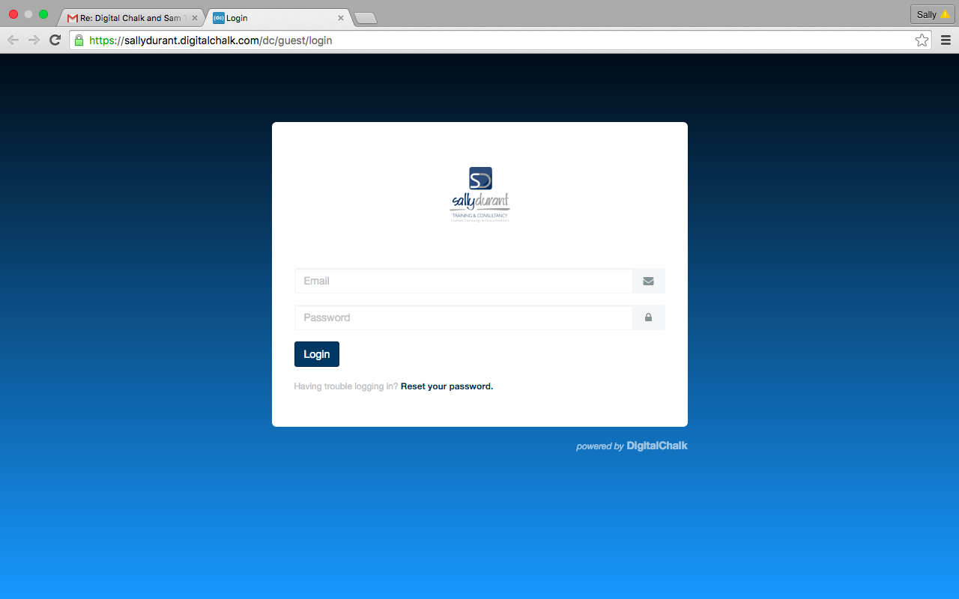

STEP 3
The courses you have enrolled on will be displayed on the screen. Select the course you wish to do by clicking on the image tab

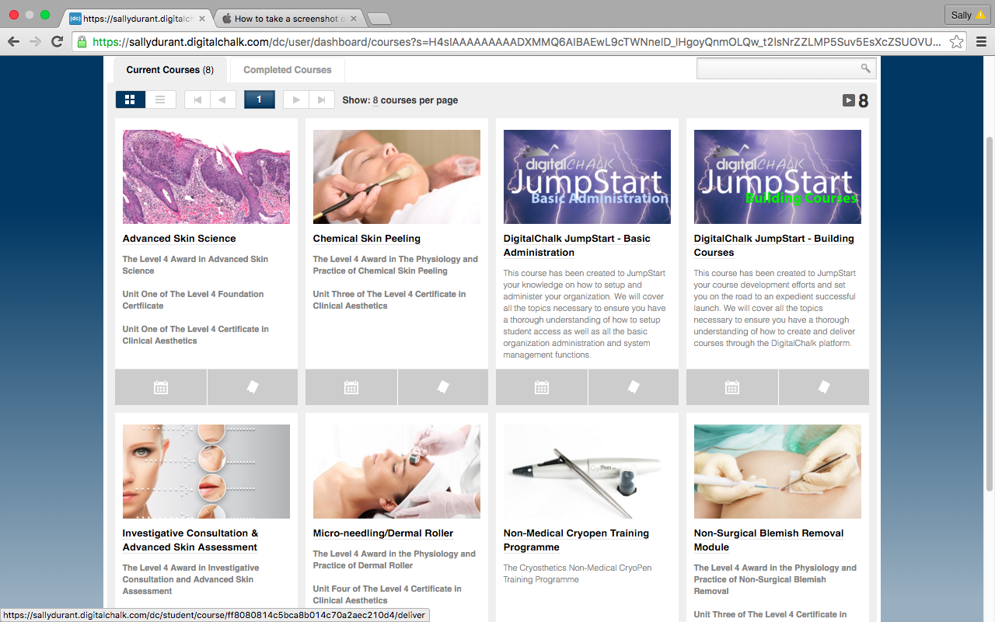

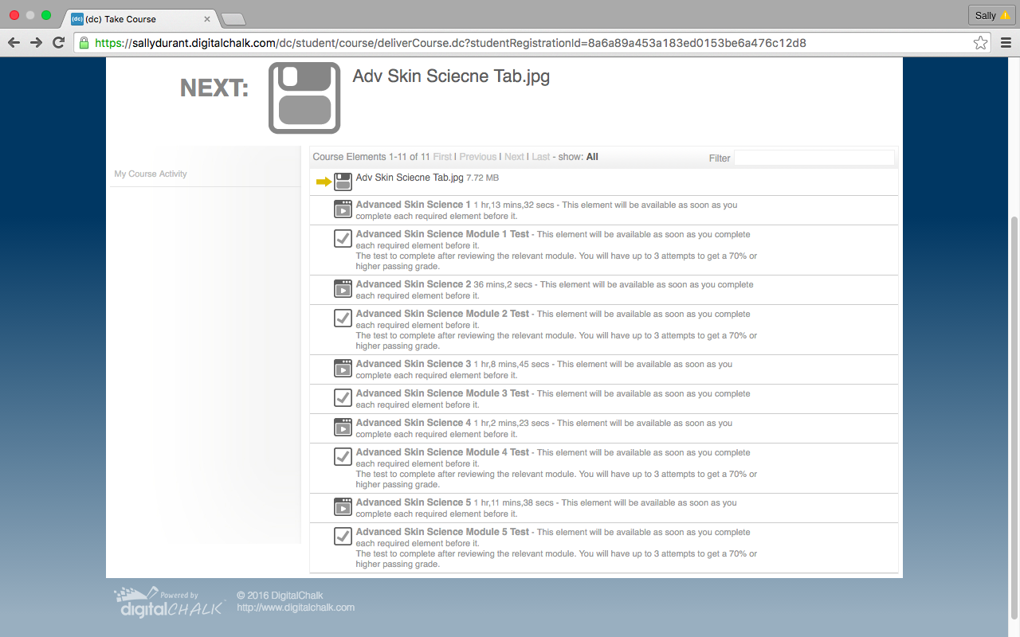
STEP 4
The list of all the course elements will appear on your screen.
A yellow arrow will indicate the first element to be completed, starting with the presentation for Module One followed by the Multiple Choice test for that section and then the assessment workbook for the course. Presentations and tests will then alternate through the course. Click on the icon to the left of the element title to open that element. You will be able to back to previous modules but you will not be able to access the next module presentation until you have passed the previous test.

STEP 5

- Once you have clicked on the icon for the course element you will see the video screen. Click on the arrow to start the video playing, making sure you have your sound turned on.
- We strongly recommend that you use head phones as this will help you focus closely on what is being said in the audio commentary
- On the left side panel you will see ‘chapters’ which will mark different points in the presentation so that you can go straight to the point where you left of on your previous session. You can use these chapter points to rewind the presentation or alternatively you can use the slider bar at the base of the screen to forward and rewind the slides – you will need to pause the presentation in order to use this function.
- You can make the video play in full screen by clicking on the crossed arrows on the bottom right of the screen
- You can view the online presentations as many times as you wish during your course completion period but you will be unable to progress from one module to another without passing the modular MCQ tests for each – see below

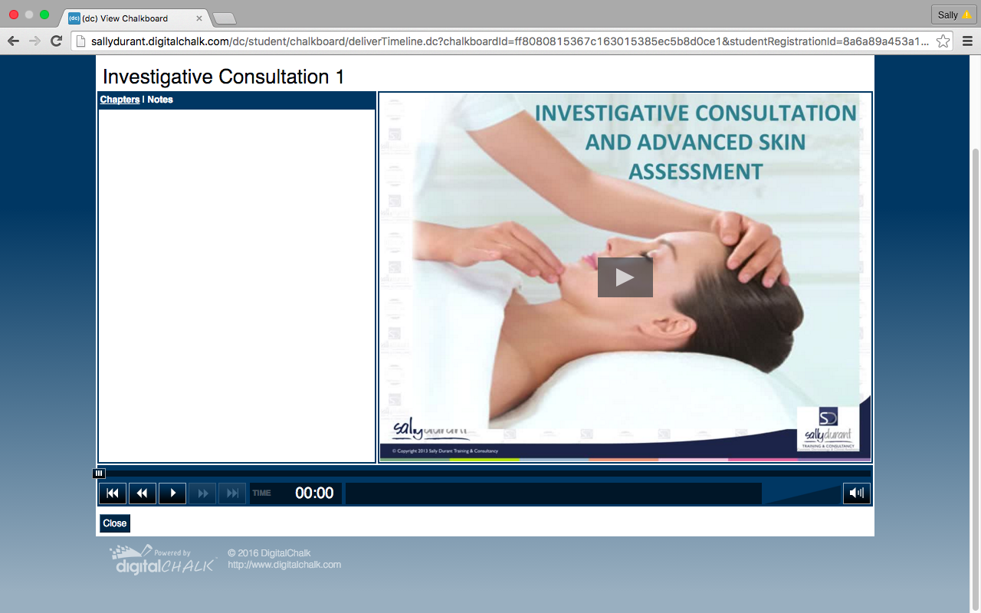

TAKING YOUR MCQ TESTS

You will seethe multiple choice tests at the end of most modules of study. They are set to a pass mark of 70% and are marked automatically so you will get your result straight away. f you don’t succeed in achieving the pass mark initially then you will be allowed to retake the test a second time and third time if necessary. The test answers will jumble up for each retake. If you have any problems please contact your course tutor.

While you can use your notes to complete these tests and so they can be used to consolidate your learning. However if you want to prepare yourself fully for your examination you should revise your work before taking the test and try to answer the questions from memory

NB Once you have taken your test the system will consider that you have finished that module and you will not be able to go back into that presentation so make sure you are happy that you have viewed it fully and made all the notes you need before you take the test

If you have any problems accessing the different elements of your course please contact it.support@sallydurant.com

