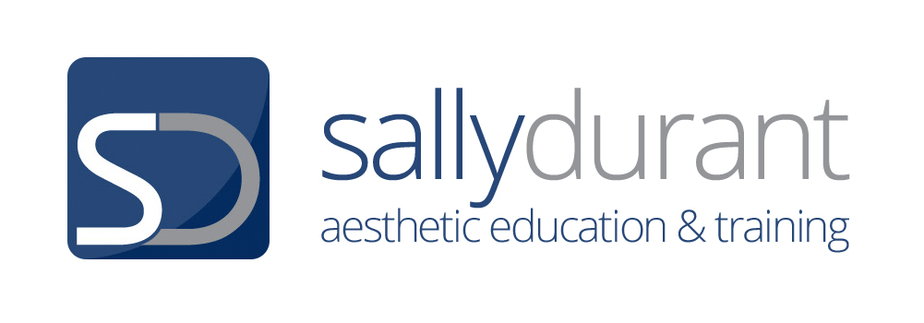

TREATMENT PROTOCOLS FOR MICRONEEDLING (MANUAL ROLLER)

PREPARATION OF TREATMENT AREA

Your working area must be clinically prepared and cleaned down to negate any risk of cross infection:

- Use a clinical disinfectant (e.g. Clinisept) to clean down the trolley, light magnifier, camera, product containers, etc.
- Bowls for cotton wool / gauze must be disinfected
- All consumables must be single use / disposable items

TROLLEY REQUIREMENTS

- Gloves (you will need three pairs)
- Small bowl containing gauzes or cotton wool
- 1 large bowl containing warm water
- Cleansing product
- Disposable hair band / cap
- Topical Anaesthetic Cream (either LMX4 / Emla Cream)
- Cling film if required for occlusion of anaesthetic cream
- Micro-needling device
- Sharps box
- Yellow bag for soft clinical waste
- Clinical disinfectant – to be used between each stage of procedure
- Camera

DOCUMENTATION REQUIREMENTS

- Consultation and skin health assessment form
- Contraindication check list
- Past treatment records to include access to previous clinical photographs
- Informed consent for application of topical anaesthetic cream
- Informed consent for procedure
- Consent to clinical photographs
- Skin assessment form
- Treatment recording and review documents
- Pre- treatment information sheet
- Post treatment aftercare sheet

THE MANUAL MICRO-NEEDLING PROCEDURE

STEP 1 - CONSULTATION AND INFORMED CONSENT

- Conduct an initial consultation to establish contra-indications and treatment restrictions
- Gain consent for clinical photographs
- Gain consent for application of topical anaesthetic cream
- Take informed consent for treatment

STEP 2 - CLIENT PREPARATION AND SKIN CLEANSE

- Remove clients shoes, jewellery and upper garment and place in designated storage container
- Cover the client / protect the area with bedroll tissue
- Wash your hands
- Cover the client’s hair with a disposable cap / hair band
- Cleanse the skin thoroughly (double cleanse) with an oil free cleansing product and pat dry. If client is wearing heavy make-up use cream cleanser for Cleanse 1 and oil free cleanser for Cleanse 2
- Skin Assessment using light magnifier

STEP 3 - TAKE PRE-PROCEDURAL PHOTOGRAPHS

- Use a device that is designated for your clinic use only – i.e. photographs should not be taken on a private phone or other personal digital device. This is a requirement of Data Protection Law
- Sit the client up so that they are as close to 90° as is comfortable
- MAKE SURE TO LABEL PHOTOS: ‘before’ and ‘after’
- Position your camera at around 12 inches from the treatment area and take three photographs:
- Full frontal
- To the right side
- To the left side
- Keep client in seated position whilst taking photos and use the same position/area to take all before and after photos

STEP 4 - APPLICATION OF TOPICAL ANAESTHETIC CREAM

- Wearing surgical gloves, apply the topical anaesthetic cream on the entire treatment area ensuring full coverage
- Apply an even layer and allow the recommended time stated on the pack for the anaesthetic to work
- Occlude with cling film if required to enhance effect
- Check every 10 minutes for numbing of skin tissue

STEP 5 – CONSULTATION AND CONSENT

- Conduct the full consultation process to include skin health assessment and establish client suitability for treatment / restrictions to treatment
- Treatment review to incorporate all information relating to treatment procedure, anticipated client experience and potential risks
- Assess and manage expectations

STEP 6 - PRACTITIONER PREPARATION

- Wash your hands before commencing and as required during and after
- At point of commencing the needling procedure, ensure you put on 2 pairs of gloves (to protect hands from the needle stick injury)

STEP 7 – REMOVAL OF ANAESTHETIC AND SKIN DISINFECTION

- Check the skin has reduced sensation
- Thoroughly remove the anaesthetic. Use an oil free facial wash if suitable or otherwise use warm water. Dry the skin
- Follow with a skin disinfection solution to the area. Soak gauze or cotton pads in the skin disinfection solution and wipe over the area to be treated. Pat skin dry

STEP 8 - PREPARATION OF DEVICE

- Remove the roller from the sterile packaging and place it in the holder. The roller has already been sterilised with gamma radiation at manufacture, so it does not need any further sanitisation. It is ready for use

STEP 9 - ZONAL MICRONEEDLING

- Imagine you have divided the face into small, squared sections. Start from the forehead and work your way down and around the face, finishing on the nose
- A clinical pencil may be used to draw these divisions onto the face if you feel this will help you

STEP 10 - ROLLERING TECHNIQUE

- Systematically work in small squares over the whole of the facial area. This pattern can of course be altered to cater for individual client preferences, but care must always be taken to treat each section of the face evenly and equally
- Hold the skin taught but with care to avoid needle stick injury
- Use the roller with slight pressure
- Roll over the first skin section, using short, back and forth motions:
- In horizontal straight lines for 3 repetitions. Lift the roller and move it slightly, and then repeat the rollering motion until you have covered the section (union jack method). For each line of application you should slightly overlap the area already covered
- Repeat in a vertical direction
- Repeat in a diagonal axis
- Repeat in the other diagonal direction.

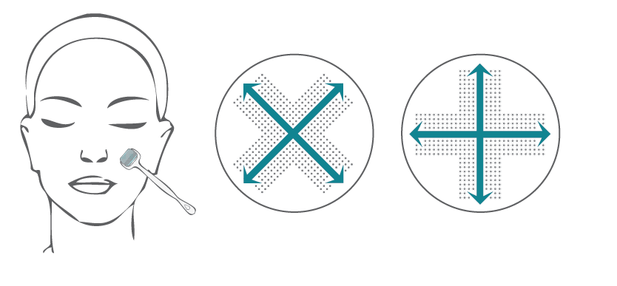

NB

- Assess for client comfort as you proceed. Ask the client to assess the pain comfort on a scale from 1 -10. 1. indicating the sensation cannot be felt at all and 10. being intolerable. Adapt to suit the client needs

- Neck and décolleté treatments are usually carried out at separate appointments. It is important not to over treat if adverse reactions are to be avoided.

STEP 11 - POST TREATMENT CARE

- Once all of the treatment area has been treated, use a skin disinfectant to remove all traces of blood by dabbling the area lightly (do not rub)
- To cool and soothe the skin apply a cold compress of sterile gauze strips soaked in skin disinfectant to the treatment area

STEP 12 – POST TREATMENT PHOTOGRAPHS

- Remove one pair of gloves so that you now have the clean pair remaining
- Take post treatment photos as in STEP 3

STEP 13 - AFTERCARE AND DOCUMENTATION

- Explain the homecare instruction and give the client the aftercare leaflet to take away
- Record all treatment details

POINTS TO NOTE

Erythema

- When rollering you must aim to keep your pressure and coverage even
- You will see an immediate erythematic reaction on the skin. You need to ensure this reaction is even all over wherever possible. However avoid over treatment
- The central cheek area will require a more thorough skin stretch and greater pressure in order that the needles insert into the softer tissue (i.e. there is no bone to act as resistance and facilitate needle penetration)

Pin-Point Bleeding

- Pin-point bleeding indicates your needles have reached dermal tissue. It is not always possible to get pin-point bleeding as this is determined by the needle length used and the skin type and condition. Needles of 0.5mm will however usually produce pin-point bleeding, especially on areas where the skin is finer e.g. the upper cheek, temples and forehead

Blood Removal

- Blood may be removed with a gauze dampened in skin disinfectant during treatment, or left and removed when the blood has dried after the treatment has finished (do not rub)
- Some medical practitioners advocate leaving blood on the skin during the treatment as it bathes the treatment area with the vital nutrients, growth factors and blood cells that are responsible for regeneration

